# Static Application Security Testing (SAST) using SonarQube

**Tool Used:** SonarQube (Dockerized)  
**Platforms:** Windows + Docker + Mendix Applications

**1. Overview**

This section documents the step-by-step process of implementing **SAST using SonarQube**, analyzing three Mendix-based applications:

* **Coffee Service App**
* **Purchase Request Mendix App**
* **Task Tracker Mendix App**

The process includes:

* Setting up SonarQube in Docker
* Configuring project keys and tokens
* Running scans via Docker SonarScanner
* Analyzing vulnerabilities and security hotspots
* Generating reproducible scripts for other researchers

**2. Step-by-Step Guide (Windows + Docker + SonarQube)**

**Step 1: Install & Verify Basics (One-time)**

* Install **Docker Desktop (WSL2 backend)**
* Verify PowerShell is installed
* Check Docker is running:

docker version

**Step 2: Start SonarQube in Docker (One-time)**

Run or reuse a container named sonarqube on port 9000:

docker ps -a --filter "name=sonarqube"

docker run -d --name sonarqube -p 9000:9000 sonarqube:lts-community

Login to SonarQube at <http://localhost:9000> using admin/admin and set a new password.

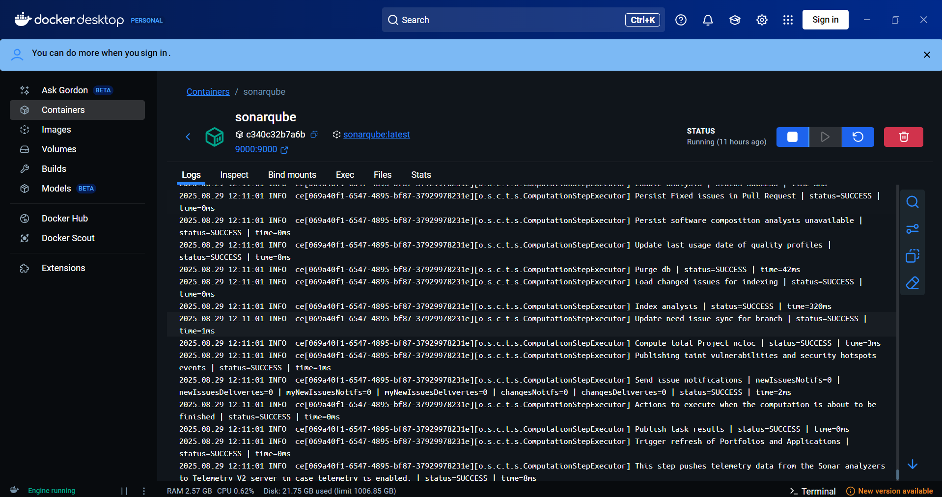

**Figure 1: SonarQube Setup on Docker**

**Step 3: Create SonarQube Projects (One-time)**

|  |  |
| --- | --- |
| Project Key | Project Name |
| Coffee-Service-App | Coffee Service App |
| Purchase-Request-Mendix-App | Purchase Request Mendix App |
| Task-Tracker-Mendix-App | Task Tracker Mendix App |

Set project keys to match each repository’s **sonar-project.properties** file.

**Step 4: Generate Project Token (One-time)**

* Navigate: *Avatar → My Account → Security → Generate Tokens*
* Name: mendix-sast → Generate → Copy token (e.g., squ_...)

Set PowerShell environment variables:

$env:SONAR_HOST_URL = "http://host.docker.internal:9000"

$env:SONAR_TOKEN = "squ_...paste-your-token..."

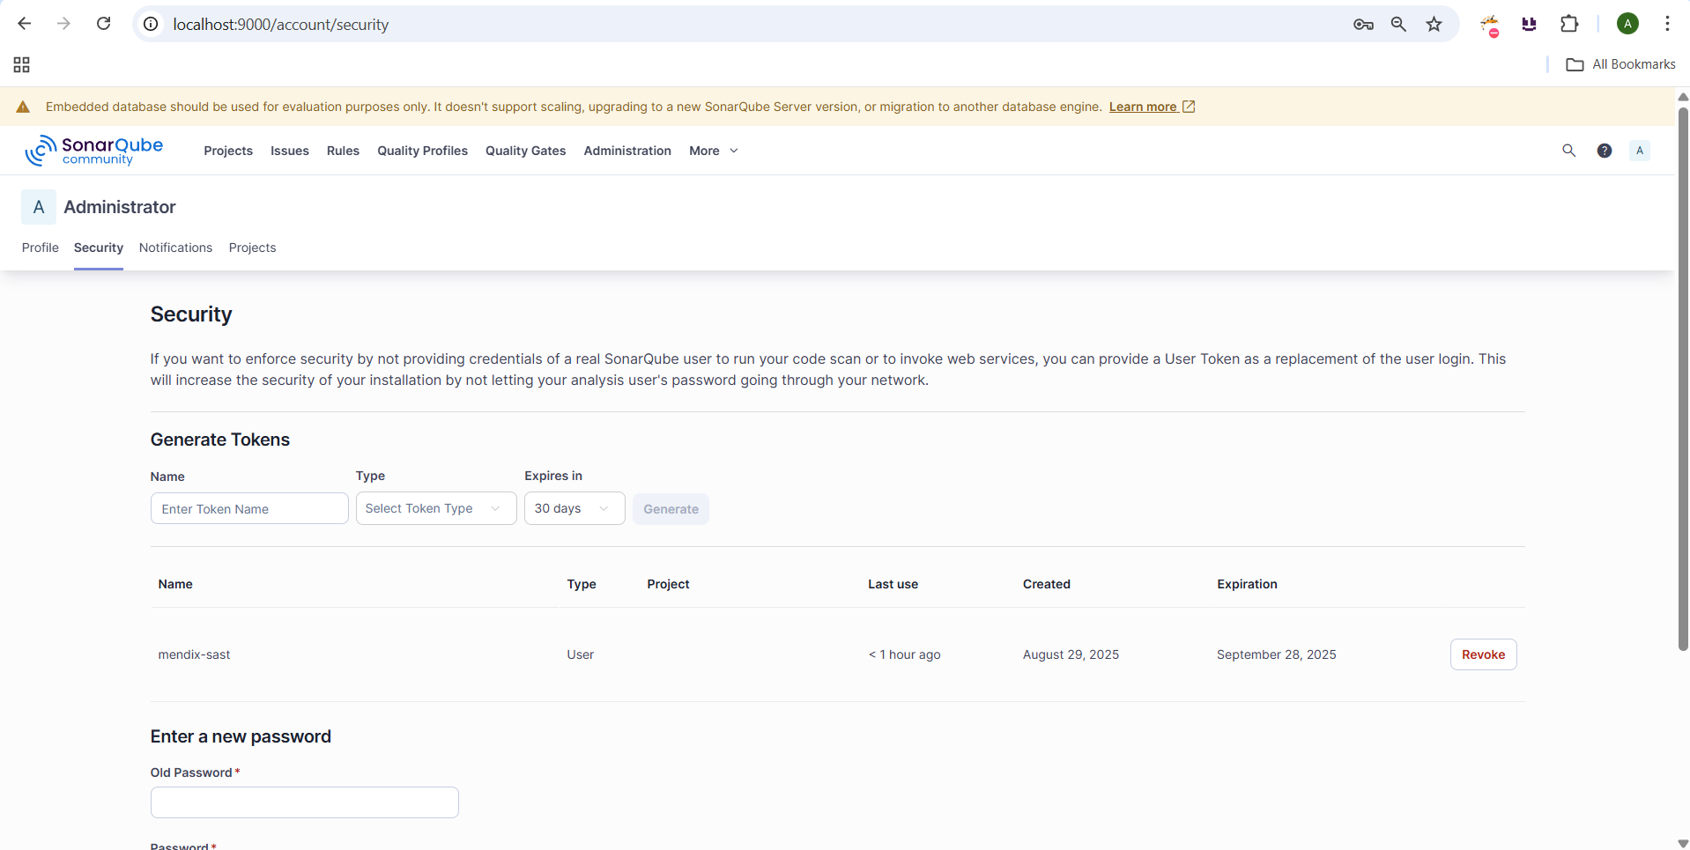

**Figure 2: Token Generation Screen**

**Step 5: Ensure Code Folders Exist**

* Coffee: C:\Users\anshu\Mendix\Coffee_Service-main

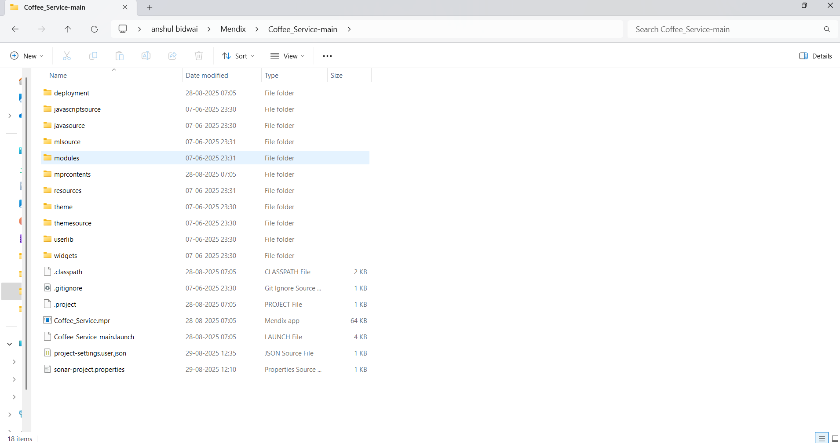

* Purchase: C:\Users\anshu\Mendix\PurchaseRequestSecurityTest-main

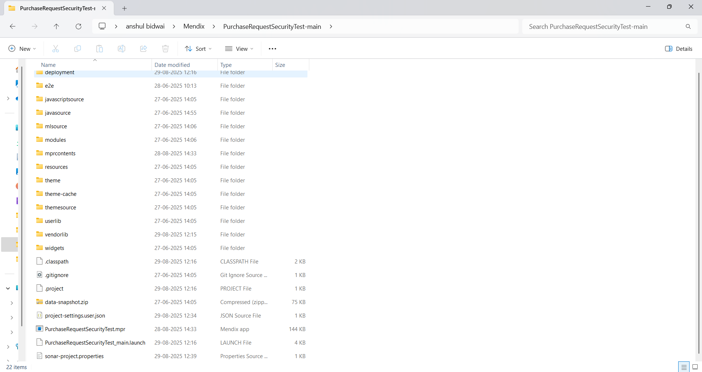

* Task Tracker: C:\Users\anshu\Mendix\TaskTrackerSecurity-main

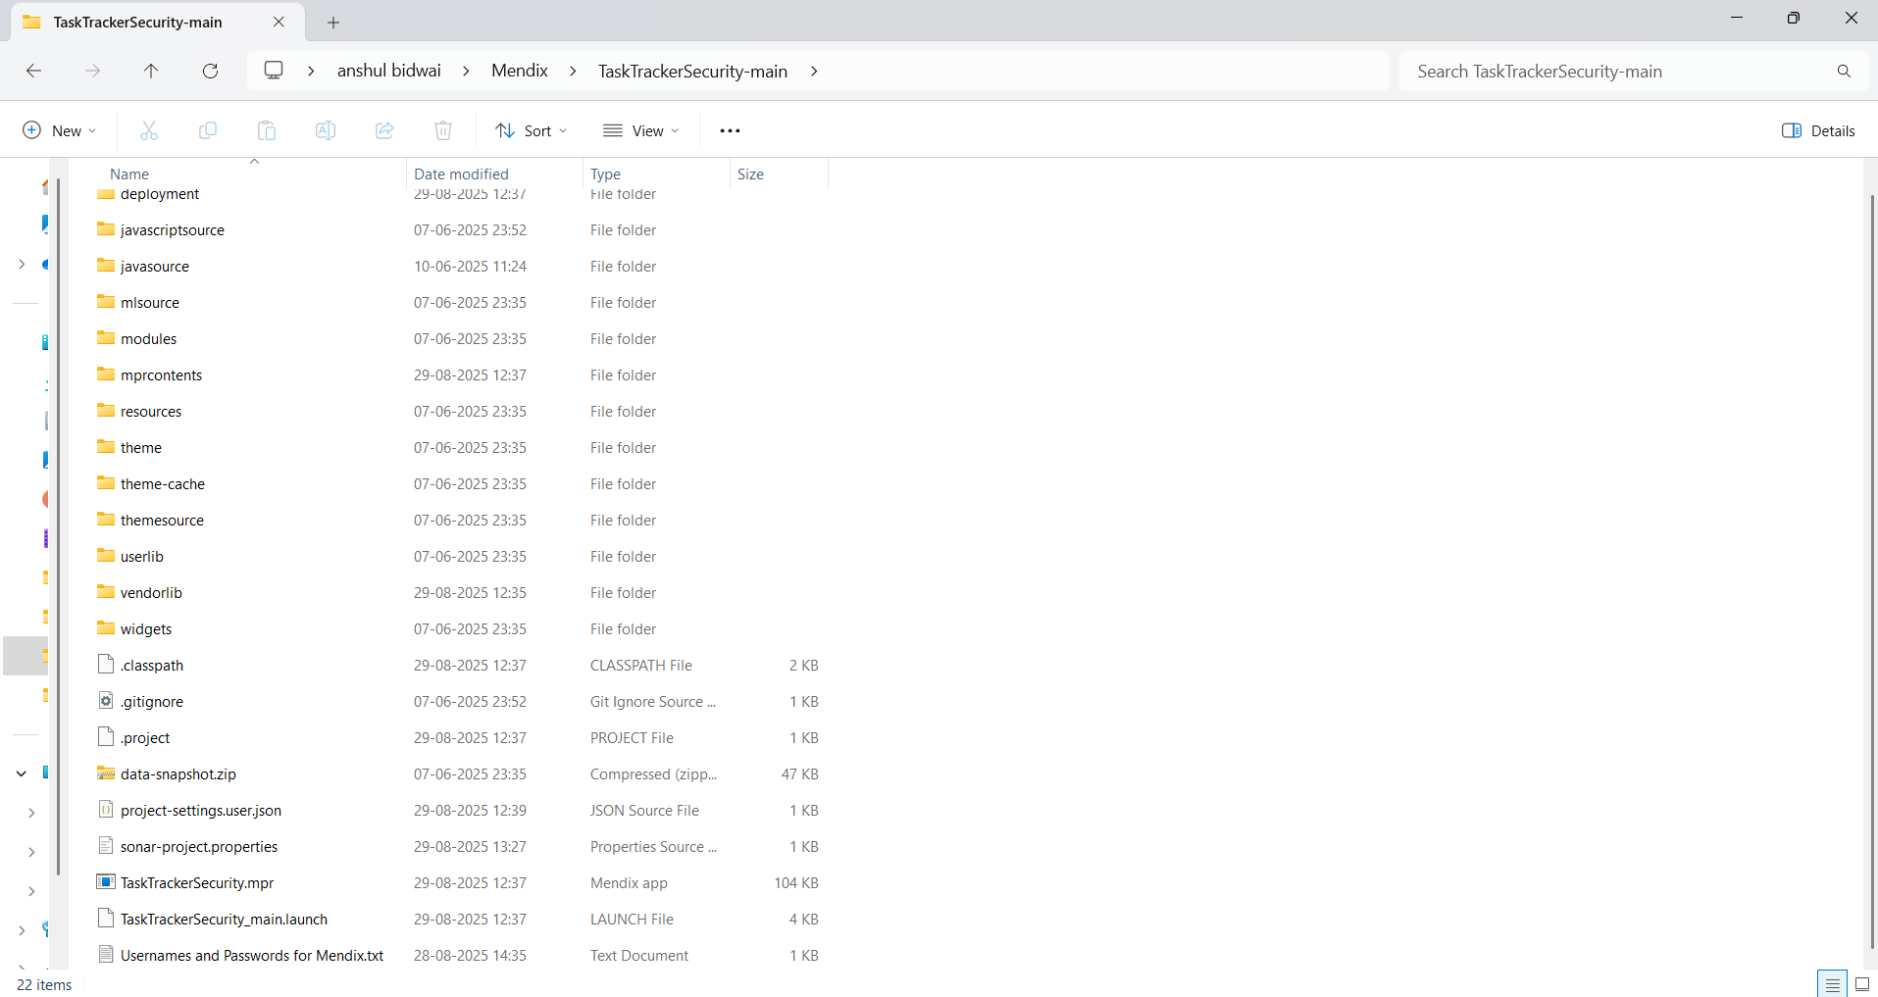

**Step 6: Add sonar-project.properties to Each Repository**

Example for **Purchase Request App**:

sonar.projectKey=Purchase-Request-Mendix-App

sonar.projectName=Purchase Request Mendix App

sonar.projectVersion=1.0

sonar.sources=.

sonar.sourceEncoding=UTF-8

sonar.java.binaries=deployment/run/bin

sonar.scm.disabled=true

sonar.exclusions=deployment/**,themesource/**,node_modules/**,**/*.min.js,**/*.map

sonar.javascript.node.maxspace=6144

This ensures stable analysis by excluding large auto-generated files.

**Step 7: Run SonarScanner for Each App**

Example for **Task Tracker App**:

docker run --rm `

-e SONAR_HOST_URL=$env:SONAR_HOST_URL `

-e SONAR_TOKEN=$env:SONAR_TOKEN `

-v "C:\Users\anshu\Mendix\TaskTrackerSecurity-main:/usr/src" `

sonarsource/sonar-scanner-cli "-Dsonar.javascript.node.maxspace=6144"

**Step 8: Confirm Results in SonarQube**

* Coffee: http://localhost:9000/dashboard?id=Coffee-Service-App
* Purchase: http://localhost:9000/dashboard?id=Purchase-Request-Mendix-App
* Task: http://localhost:9000/dashboard?id=Task-Tracker-Mendix-App

**3. Key Vulnerability Example: Weak Cipher Mode**

**Issue**

*Use another cipher mode or disable padding.*  
This vulnerability exposes encrypted data to potential plaintext recovery attacks.

**Impact**

* Theft of sensitive data
* Tampering with encrypted messages
* Reduced cryptographic strength

**Noncompliant Code (AES/CBC)**

import javax.crypto.Cipher;

public static void main(String[] args) {

Cipher.getInstance("AES/CBC/PKCS5Padding"); // Noncompliant

}

**Compliant Code (AES/GCM)**

import javax.crypto.Cipher;

public static void main(String[] args) {

Cipher.getInstance("AES/GCM/NoPadding"); // Secure

}

**4. For Other Researchers (Reproducible Setup)**

* Ready-to-use **PowerShell script (run-sast.ps1)**
* Portable **sonar-project.properties templates**
* Handles:
  + Java binaries pathing
  + Git SCM disabled for Docker
  + Large JS bundle exclusion
  + Node heap tuning (6144 MB)

**How to Run**

$env:SONAR_HOST_URL = "http://host.docker.internal:9000"

$env:SONAR_TOKEN = "squ_your_token_here"

powershell -ExecutionPolicy Bypass -File .\scripts\run-sast.ps1 `

-CoffeeRepoPath "C:\path\to\Coffee_Service" `

-PurchaseRepoPath "C:\path\to\PurchaseRequest" `

-TaskRepoPath "C:\path\to\TaskTracker" `

-OutRoot ".\tests\SAST" `

-JsMaxSpaceMB 6144

**5. Novel Contributions & Impact**

1. **Mendix-specific SAST Stabilization** – Targeted exclusions and Java binaries pathing.
2. **Reproducible Pipeline** – Containerized, parameterized, and environment-independent.
3. **Failure Mode Documentation** – Token errors, SCM failures, Node OOM resolved systematically.
4. **Research-Friendly Packaging** – One-command orchestration, reproducible artifacts.

**Impact:** Reliable, portable, and auditable SAST pipeline for low-code/Mendix projects.

**6. Metrics for Validation**

* **Completion Rate:** Percentage of projects that scanned successfully.
* **False Positive Reduction:** After applying exclusions.
* **Stability Improvement:** Reduction of “bridge server unresponsive” incidents.
* **Reproducibility:** Identical issue counts across machines.

**7. Artifacts Provided**

* /scripts/run-sast.ps1
* sonar-project.properties templates
* tests/SAST/<app>/scanner.log

# Dynamic Application Security Testing (DAST) – Coffee Service Application

**A. Tools and Configuration**

* **Tool:** OWASP ZAP
* **Proxy Configuration:** FoxyProxy used for interception

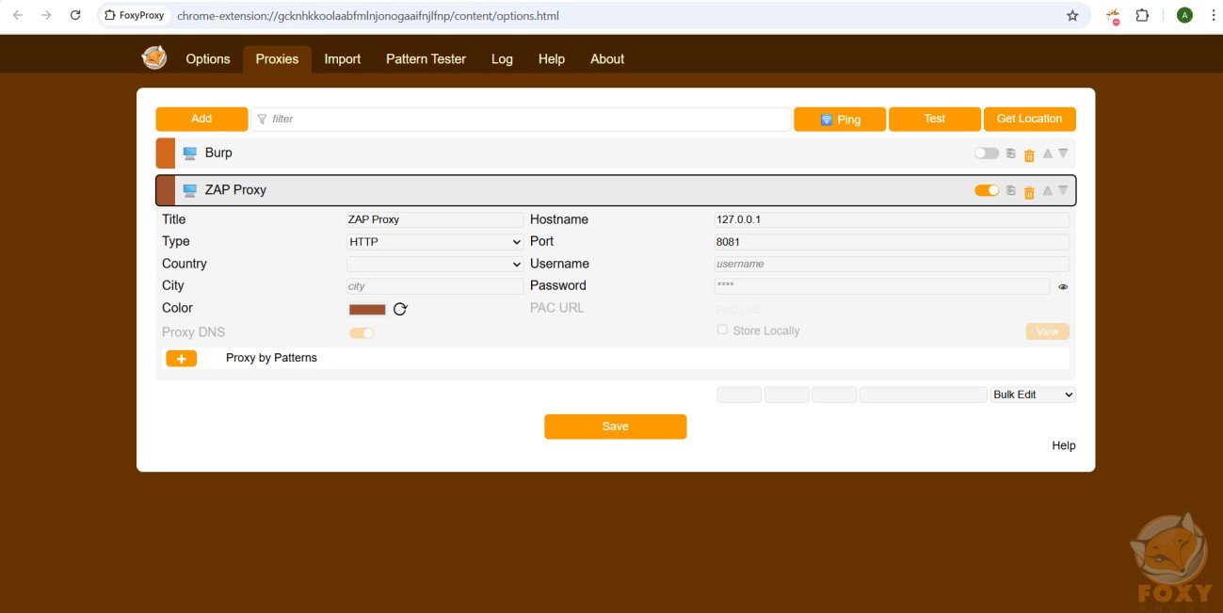

*Fig. 1: Zap Proxy Setting Using FoxyProxy*

* **API Testing:** Postman for manual endpoint validation

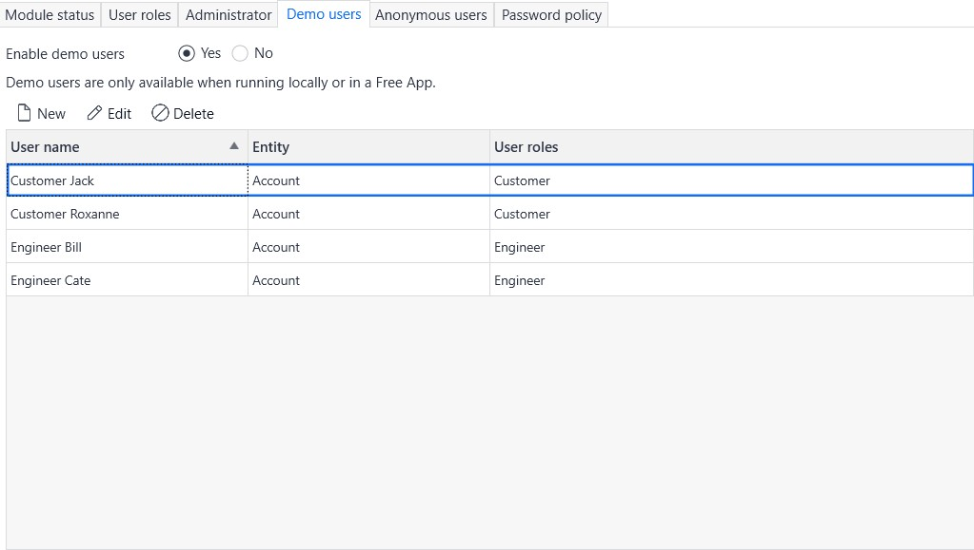

*Fig. 2: Postman for API Testing*

**B. Authentication Security Testing**

**1. Login Brute Force**

* **Goal:** Assess resistance against brute-force login attempts (lockout, rate-limiting, CAPTCHA).
* **Tool:** OWASP ZAP Fuzzer

**Steps:**

1. **Fuzzing Login Endpoint**
   * Intercepted login request, selected password parameter, applied common password wordlist.

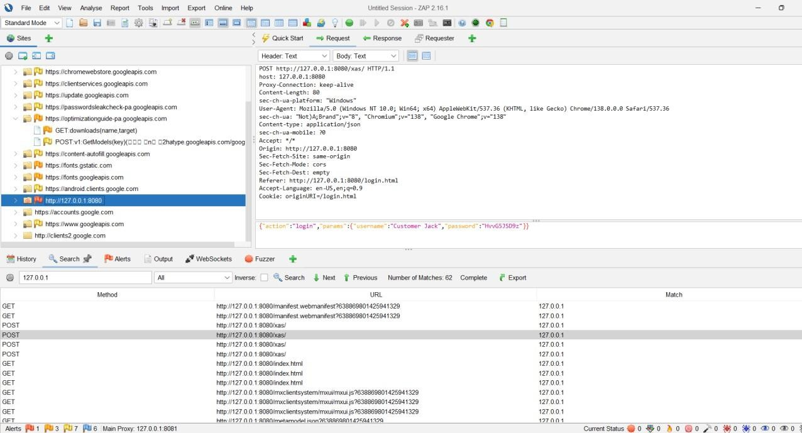

*Fig. 3: Fuzz Attack Performed*

1. **Testing with Valid Credentials**
   * Sent correct username/password.

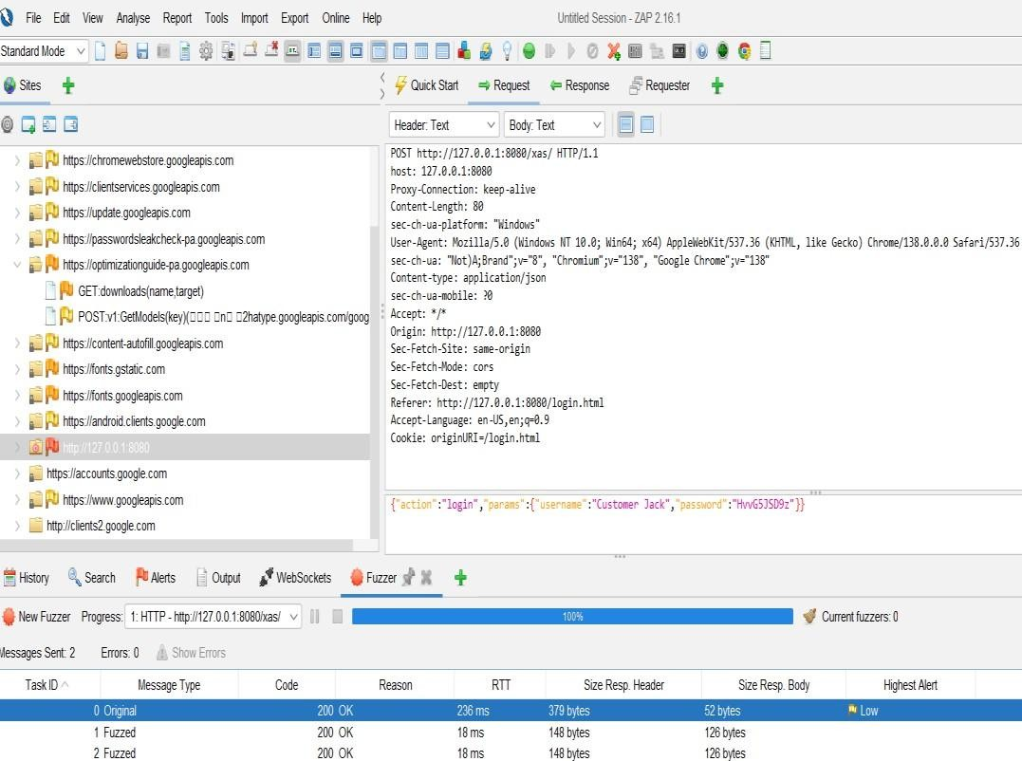

*Fig. 4: Valid Login Request*

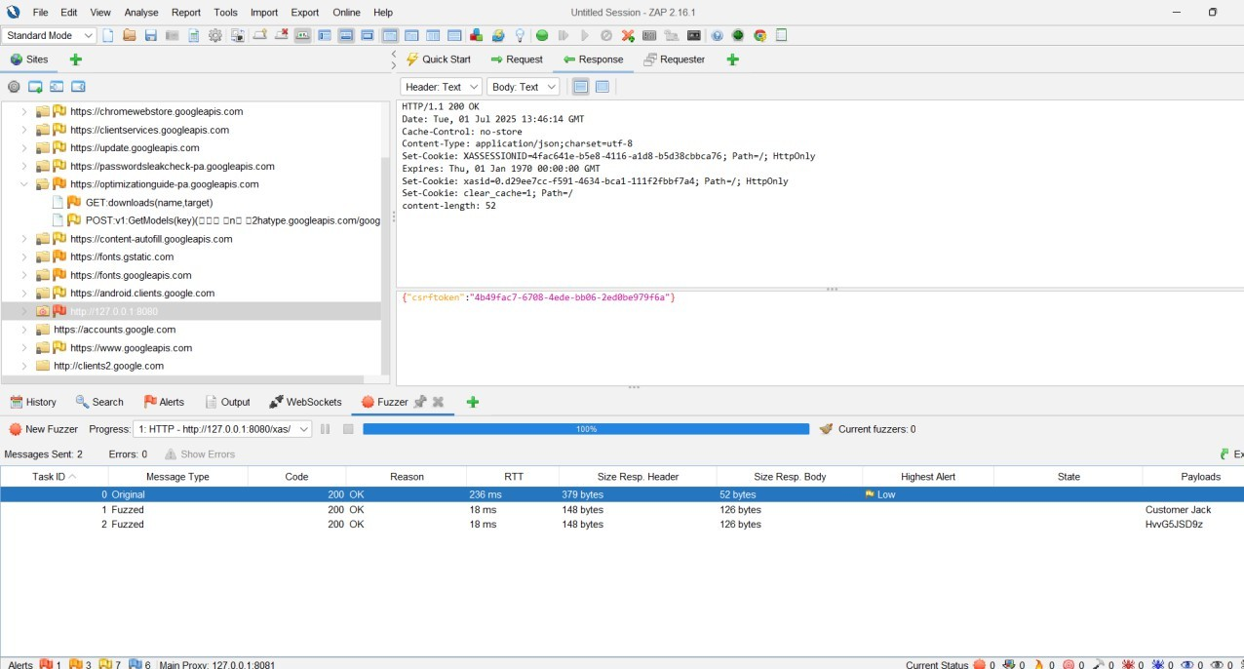

*Fig. 5: 200 OK with CSRF Token*

1. **Testing with Invalid Credentials**
   * Sent incorrect password.

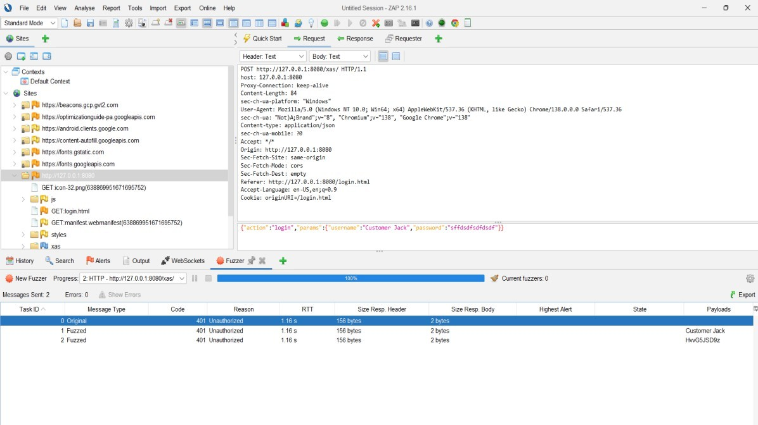

*Fig. 6: Invalid Login Request*

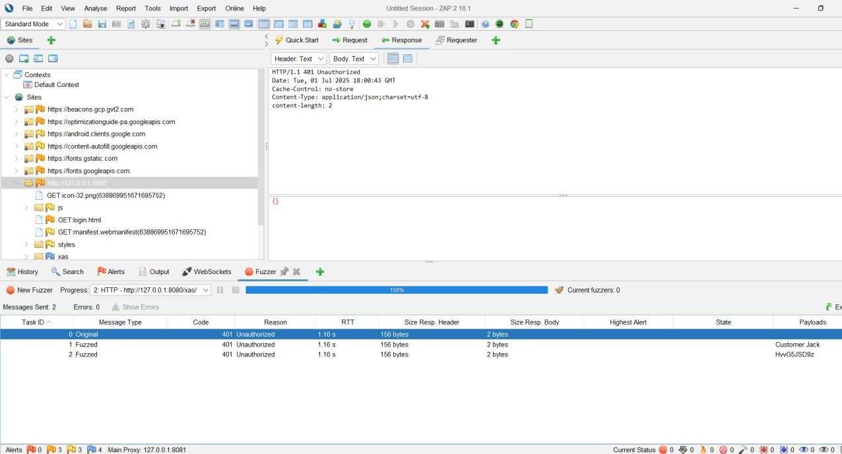

*Fig. 7: 401 Unauthorized Response*

**Results:**

* Valid credentials returned 200 OK; invalid returned 401 Unauthorized.
* No account lockout, CAPTCHA, or throttling detected.

**Impact:**

* Vulnerable to brute-force and credential stuffing attacks.

**Recommendation:**

* Implement account lockout, rate-limiting, or CAPTCHA after multiple failed attempts.

**2. Session Fixation / Reuse**

* **Objective:** Determine if stolen or reused session cookies allow unauthorized access.

**Steps:**

1. Extracted session cookie (XASSESSIONID) after valid login

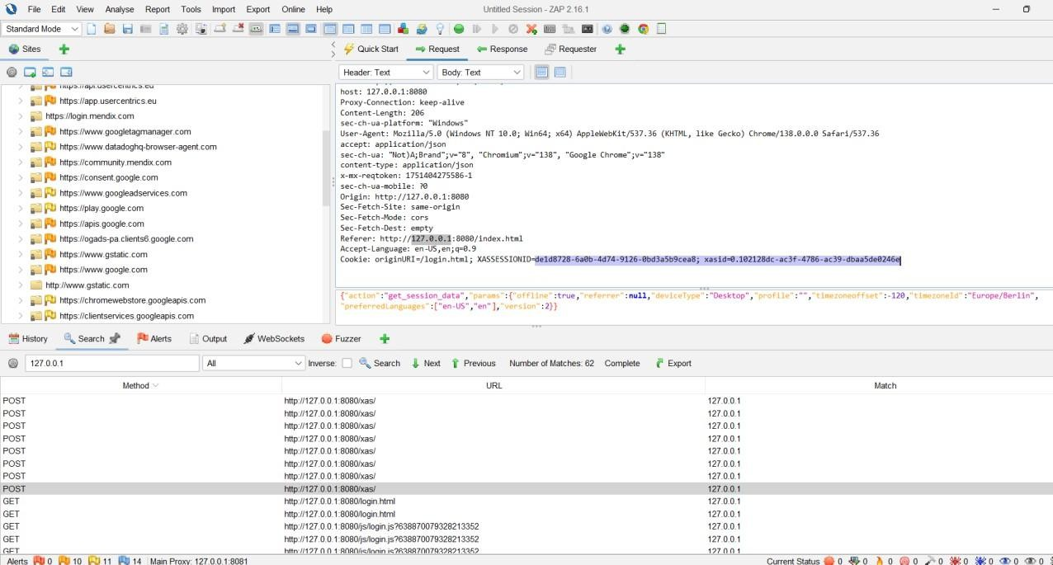

*Fig. 8: Extracted Session Cookie*

1. Inserted cookie in new browser session using Chrome DevTools.

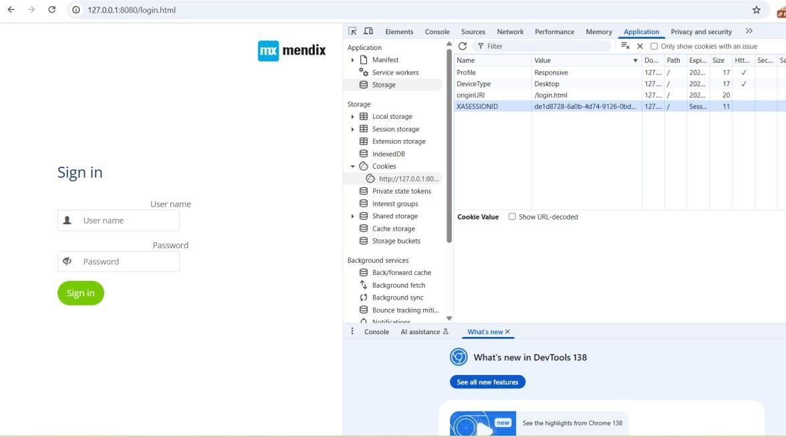

*Fig. 9: Setting Session Cookie*

1. Attempted to access protected resources.

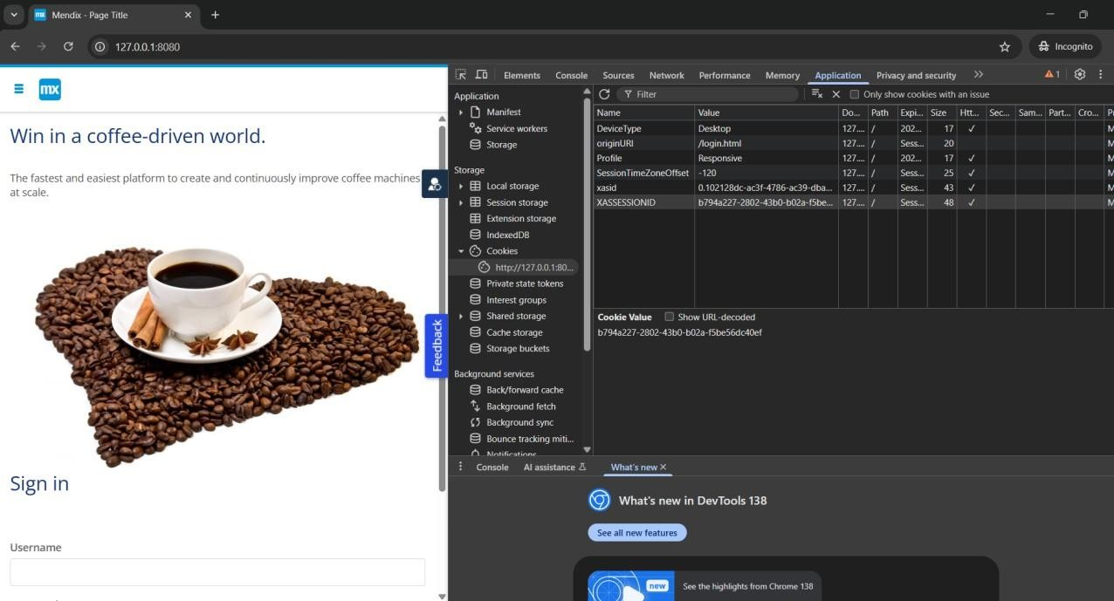

*Fig. 10: Access Attempt with Fixed Session*

**Results:**

* Reused cookies were rejected; redirected to login page.

**Conclusion:**

* Session fixation and reuse mitigations are effectively implemented.

**3. Authentication Bypass**

* **Objective:** Test if protected resources are accessible without authentication.
* **Tool:** OWASP ZAP Spider

**Steps:**

1. Ran unauthenticated spidering.

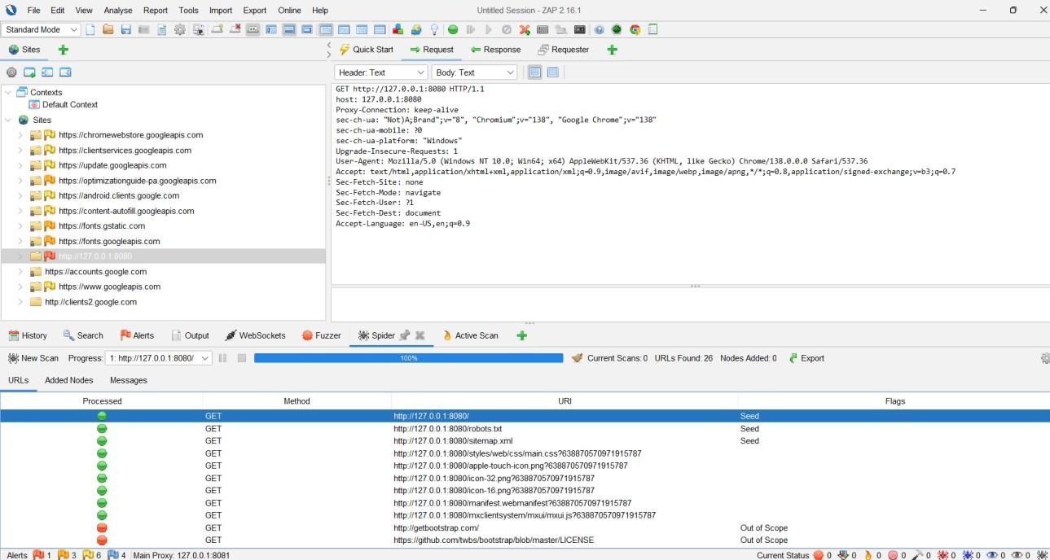

*Fig. 11: ZAP Spider Results*

1. Attempted direct access to protected pages.

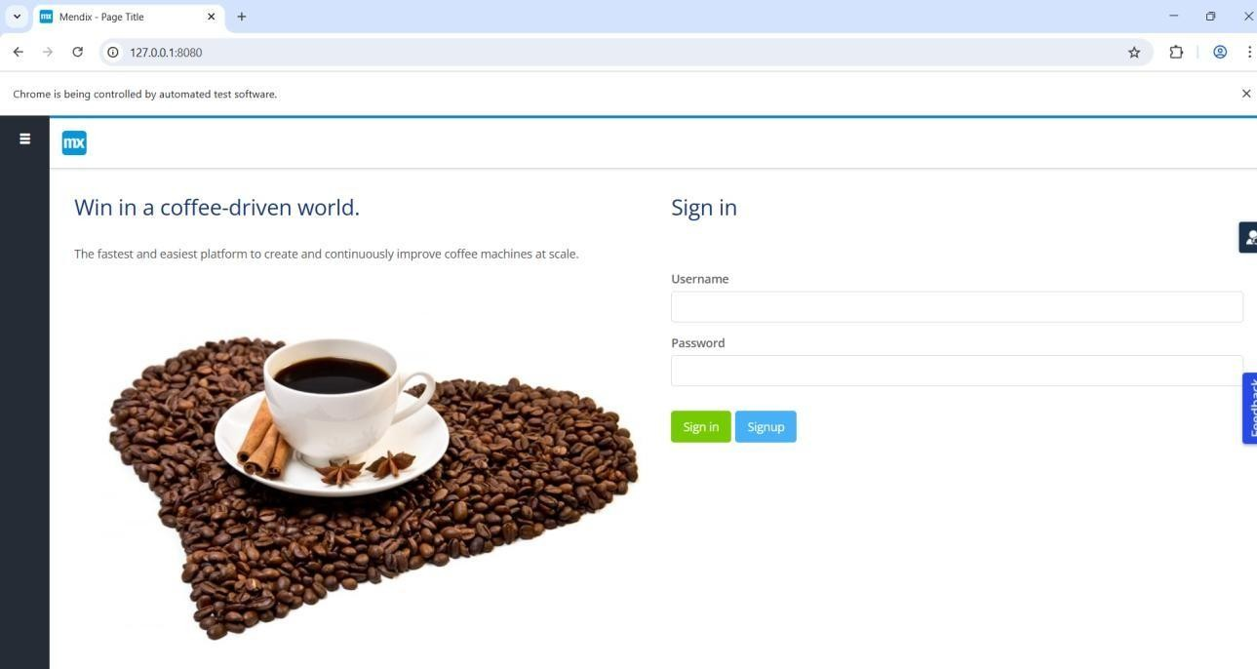

*Fig. 12: HTTP Response for Protected Page*

**Results:**

* Only static/public files (/robots.txt, /sitemap.xml) exposed.
* No protected routes accessible without authentication.

**C. Role-Based Access Control (RBAC) and IDOR**

**1. RBAC Testing**

* **Objective:** Validate access segregation among Requester, Approver, and Admin roles.

**Steps:**

1. Logged in as each role and recorded accessible URLs.

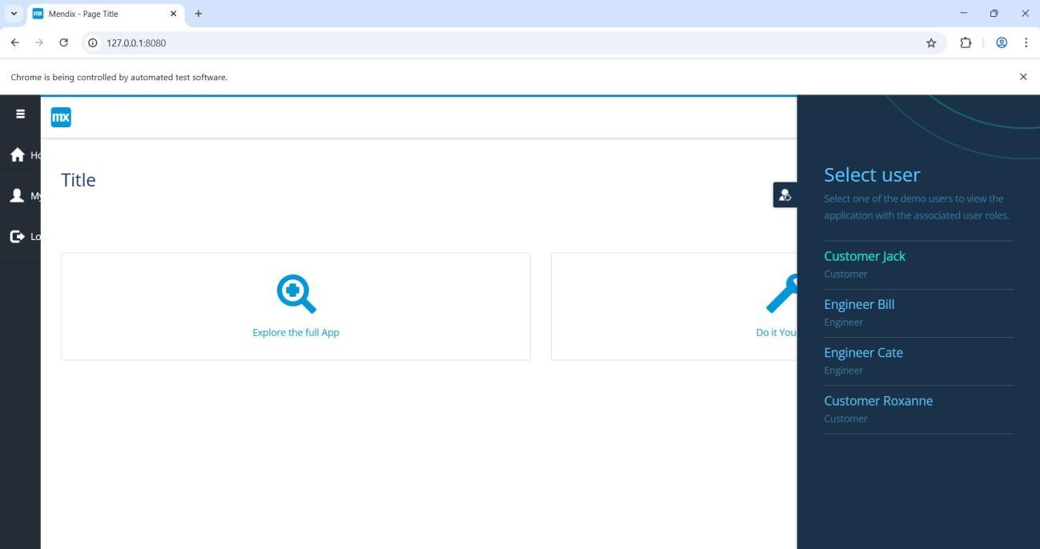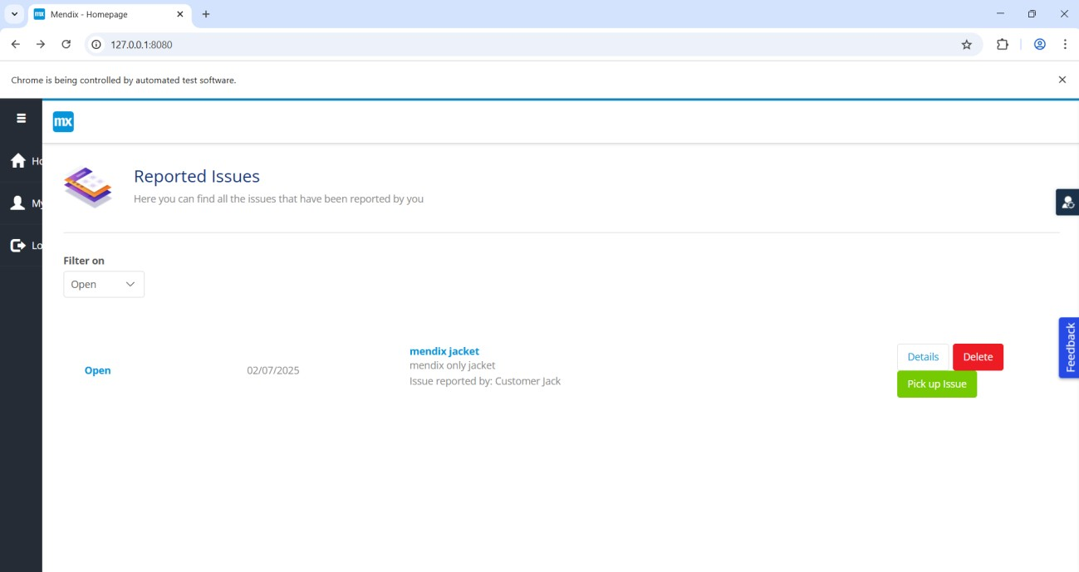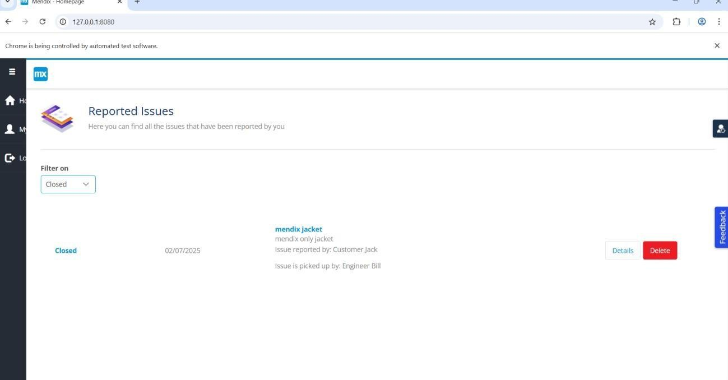

*Fig. 13: Customer Jack Dashboard, Customer Jack Task*, *New Task Added – Customer Jack*

1. Attempted cross-role access using lower-privilege accounts.

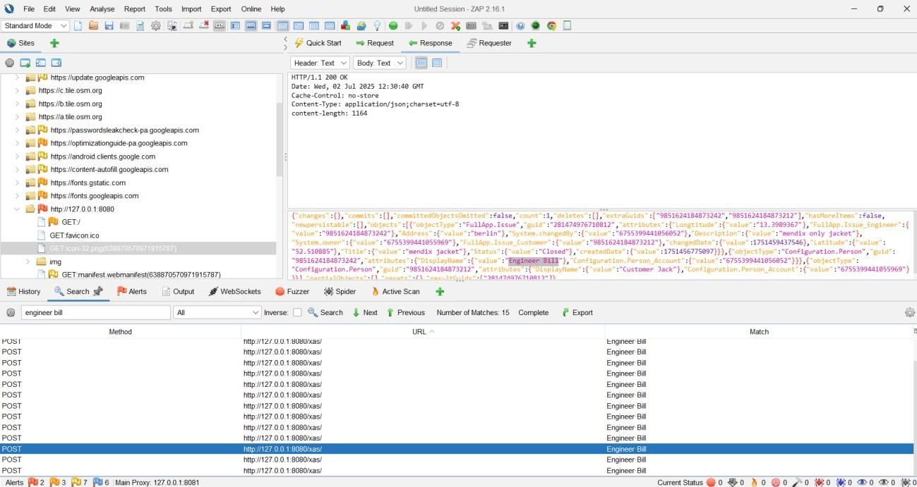

*Fig.14: Attempt to Access Engineer Bill*

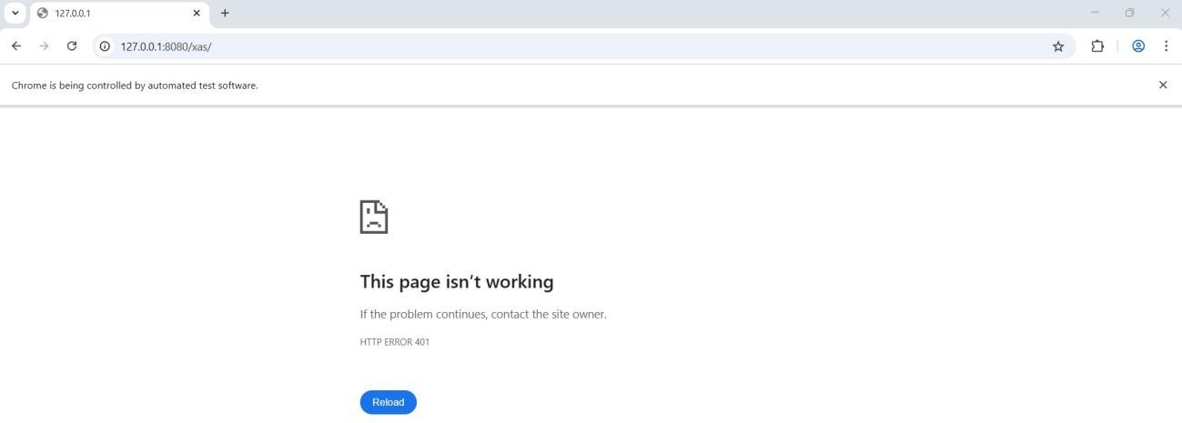

*Fig. 15: Access Denied Response*

**Results:**

* Access denied for unauthorized roles.
* No RBAC flaws detected.

**2. IDOR (Insecure Direct Object Reference)**

* **Objective:** Test for unauthorized data access via manipulated IDs.

**Steps:**

1. Identified profiledata parameter.
2. Fuzzed values (21–900) via ZAP.
3. Reviewed responses.

**Results:**

* All responses returned empty JSON ({}) with no sensitive data exposed.

**Conclusion:**

* No IDOR vulnerabilities identified.

**D. API Security and Input Validation**

**1. Unauthenticated API Access**

* **Objective:** Test if /xas/ endpoint allows unauthenticated interaction.

**Key Findings:**

* API returned 200 OK with CSRF token even without authentication cookies.

**Risk:**

* Potential unauthorized API access if CSRF token alone is sufficient.

**2. Injection Testing**

* **Objective:** Identify SQLi, XSS, or Command Injection vulnerabilities.

**Process:**

* Active scan performed on /xas/.

**Results:**

* No SQLi, XSS, or Command Injection detected.
* **Issue Identified:** Bcrypt password hashes exposed in API responses.

**E. CSRF Testing**

* **Objective:** Verify anti-CSRF protection across roles and transactions.

**Process:**

1. Passive scan during navigation. *(Fig. 1–4: Role-based Navigation and Action Pages)*
2. Active scan for missing CSRF tokens. *(Fig. 5: Active Scan Results)*

**Results:**

* No CSRF vulnerabilities detected.

**F. Other Security Issues & Information Disclosure**

**High Risk**

1. **Hash Disclosure (BCrypt)** – Hashes exposed in POST /xas/.
2. **PII Disclosure** – Credit card number leaked via POST /xas/.

**Medium Risk**

* Missing CSP header.
* Directory browsing enabled.
* Missing anti-clickjacking header.
* Spring Actuator /xas/actuator/health exposed.

**Low Risk**

* Missing HttpOnly & SameSite flags.
* HSTS not enabled.
* Missing X-Content-Type-Options.
* Timestamp leaks.
* Debug error messages exposed (/metamodel.json).

**G. Summary Table**

|  |  |  |  |
| --- | --- | --- | --- |
| **Severity** | **Issue** | **Endpoint(s)** | **Recommendation** |
| High | Hash Disclosure (BCrypt) | POST /xas/ | Remove hashes from API responses |
| High | PII Disclosure | POST /xas/ | Mask/remove sensitive data |
| Medium | CSP Header Not Set | /, /xas/ | Add Content-Security-Policy header |
| Medium | Directory Browsing Enabled | /widgets/... | Disable directory listing |
| Medium | Missing Anti-clickjacking | All responses | Add X-Frame-Options/CSP headers |
| Medium | Spring Actuator Info Leak | /xas/actuator/health | Restrict or disable in production |
| Low | Cookie Flags Missing | All cookies | Set HttpOnly, SameSite |
| Low | HSTS Not Set | All endpoints | Enable HSTS |
| Low | X-Content-Type-Options Missing | Multiple endpoints | Add nosniff header |
| Low | Debug/Info Disclosure | /metamodel.json | Suppress debug outputs |

**H. Key Recommendations**

* Remove sensitive data (hashes, PII) from API responses.
* Add missing headers: CSP, HSTS, X-Frame-Options.
* Harden cookies with HttpOnly and SameSite.
* Restrict debug and actuator endpoints in production.

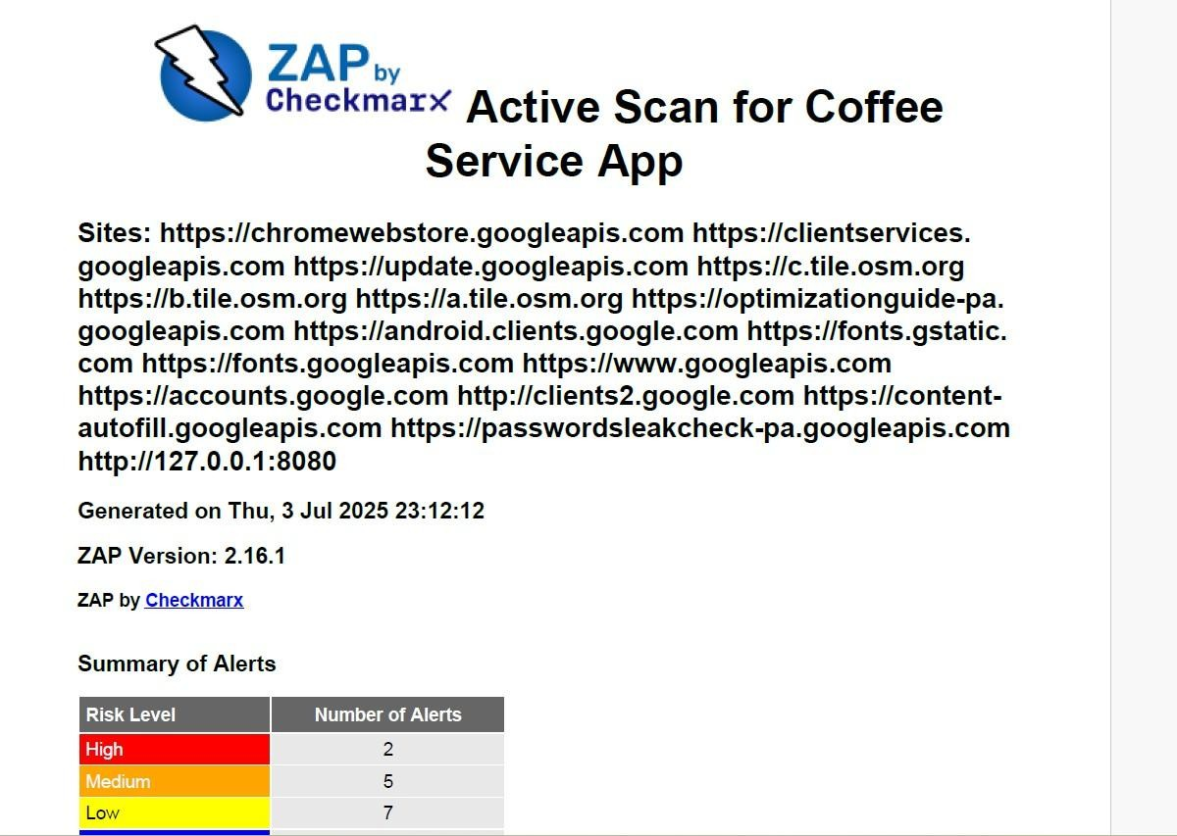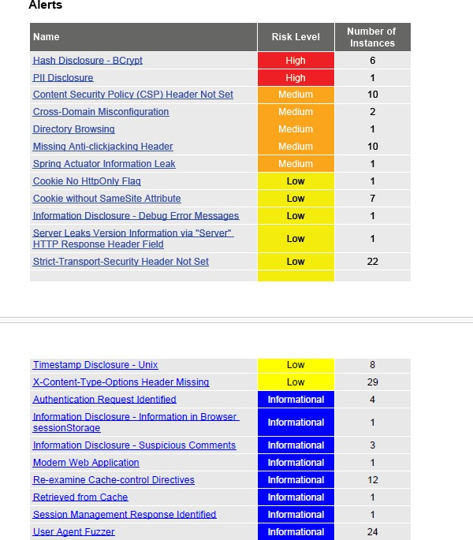

# Dynamic Application Security Testing (DAST) – Purchase Request Application

**A. Tools and Setup**

* **Tool:** OWASP ZAP (Zed Attack Proxy)
* **Proxy:** Configured for login and API traffic interception
* **Test Users:** demo_requester, demo_approver, demo_admin
* **Environment:** Pre-production instance
* **Objective:** Identify authentication, session, and access control vulnerabilities before production deployment

**B. Authentication Security**

**1. Brute-Force Login Test**

**Objective:** Evaluate resistance against automated password guessing attacks.

**Test Environment:**

* User: demo_requester
* Endpoint: /login (application login page/API)
* Tool: OWASP ZAP Fuzzer

**Steps:**

1. **Capture Baseline Login Request**
   * Intercepted HTTP POST login request using ZAP.
   * Identified username/password fields for fuzzing.
2. **Configure and Launch Fuzzer**
   * Loaded password wordlist and initiated attack.
3. **Monitor Responses**
   * Tracked status codes for each attempt.
4. **Test Correct vs. Incorrect Passwords**
   * Incorrect password returned error.
   * Correct password succeeded with CSRF token issued.
5. **Evaluate Lockout Mechanisms**
   * Performed 20–50+ attempts.

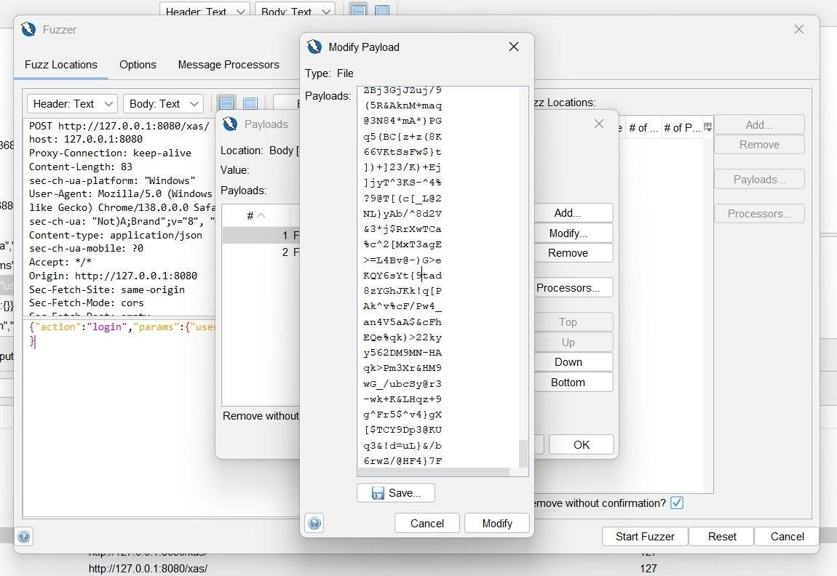

*Fig. 16: No Lockout Observed*

**Results:**

* Only valid credentials allowed login.
* No account lockout, CAPTCHA, or rate-limiting implemented.

**Impact:** High brute-force risk.

**Recommendations:**

* Implement account lockout or temporary bans after repeated failures.
* Add CAPTCHA after multiple failed attempts.
* Introduce rate-limiting (e.g., exponential backoff).

**2. Session Reuse / Fixation**

**Objective:** Test if stolen session cookies can be reused across users.

**Steps:**

1. Logged in as demo_requester and extracted session cookie.
2. Logged in as demo_approver in a separate browser, replaced cookie.
3. Attempted access with manipulated session.

**Results:**

* Session tokens cannot be reused between users.
* No session fixation vulnerability found.

**Recommendation:** Maintain current session management controls and review periodically.

**3. Login Bypass**

**Objective:** Determine if unauthenticated users can access protected resources.

**Steps:**

1. Cleared cookies; initiated anonymous access.
2. Ran OWASP ZAP Spider to enumerate endpoints.

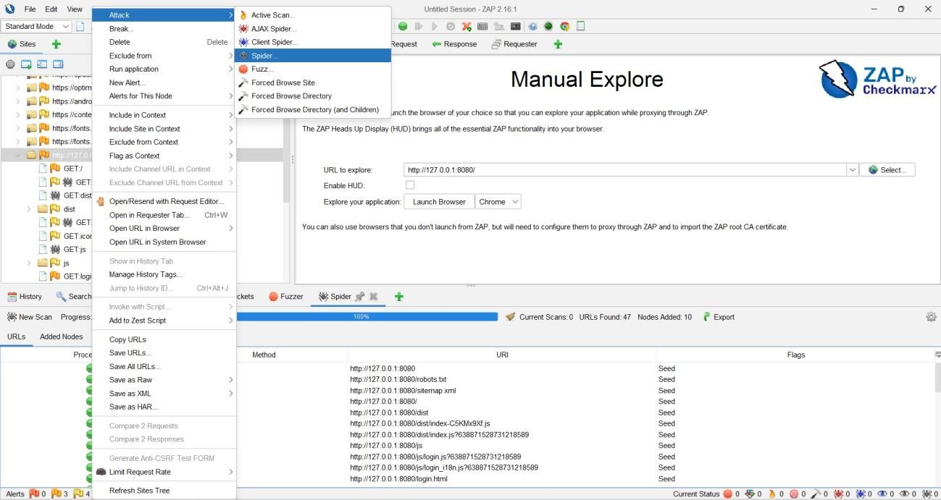

*Fig. 17: Spider in Progress*

1. Reviewed discovered URLs

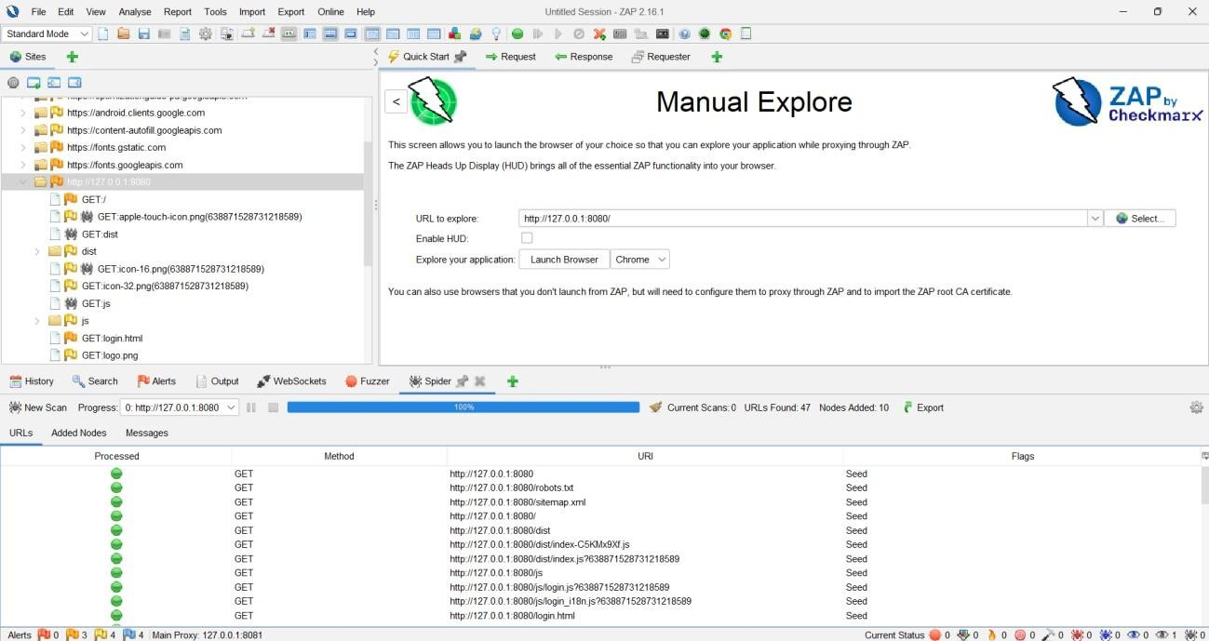

*Fig. 18: Spider Results*

1. Attempted direct access to restricted pages.



*Fig. 19: Access Denied*

**Results:**

* Only public resources accessible: landing page, login page, static files.
* All protected pages redirected to login or returned 401/403.

**Conclusion:** No login bypass vulnerabilities detected.

**C. Access Control Testing (RBAC & IDOR)**

**1. Role-Based Access Control (RBAC)**

**Objective:** Verify access segregation across Requester, Approver, and Admin roles.

**Steps:**

1. Logged in with each role individually.
2. Ran OWASP ZAP Spider for each session.
3. Compared accessible URLs per role.
4. Tested unauthorized access attempts.

**Results Table – RBAC Accessibility**

|  |  |  |  |  |
| --- | --- | --- | --- | --- |
| **URL / Endpoint** | **Requester** | **Approver** | **Admin** | **Description** |
| / | Yes | Yes | Yes | Home/Dashboard |
| /login.html | Yes | Yes | Yes | Login Page |
| /xas/ | Yes | Yes | Yes | API Endpoint |
| /PurchaseApprovals.Admin_Homepage.js | No | No | Yes | Admin Homepage |
| /PurchaseApprovals.Product_Overview.js | Yes | Yes | Yes | Product Overview |
| /PurchaseApprovals.TaskInbox.js | No | Yes | No | Approver Inbox |
| /PurchaseApprovals.Task_Approver.js | No | Yes | No | Approver Task Page |

**Findings:**

* Requesters and approvers restricted to their respective areas.
* Admin has full access.
* Unauthorized access attempts returned 403 or error page.

**Recommendation:** Maintain current RBAC configuration; review when adding new features.

**2. Insecure Direct Object Reference (IDOR)**

**Objective:** Identify unauthorized resource access via manipulated IDs.

**Steps:**

1. Located API requests with object IDs.
2. Tampered ID in request payload.
3. Observed server response.

**Results:**

* Unauthorized requests returned 401.
* No data leakage detected.

**Conclusion:** Application is not vulnerable to IDOR in tested endpoints.

**D. Key Findings**

* **High Risk:** No brute-force mitigation on login.
* **Medium Risk:** None observed in RBAC or IDOR.
* **Low Risk:** General best practices (e.g., periodic session review).

**E. Recommendations**

* Enforce brute-force protection: account lockout, CAPTCHA, and rate-limiting.
* Continue periodic review of session and RBAC controls.
* Retest after major feature changes or production deployment.

# Dynamic Application Security Testing (DAST) – Comprehensive Security Report

**1. Security Analysis – IDOR (Insecure Direct Object Reference)**

**Positive Findings**

* The application enforces proper access controls; users cannot access or modify resources they do not own by manipulating object identifiers.

**Negative Findings**

* No IDOR vulnerabilities were detected at the tested endpoints.

**Conclusion & Recommendation**

* The tested endpoints correctly enforced authorization controls, returning 401 Unauthorized when unauthorized access was attempted.
* **Recommendation:** Maintain strong access controls across all endpoints and **periodically retest** for IDOR vulnerabilities, especially after adding new features or APIs.

**2. API Security & Input Validation**

**2.1 Unauthenticated API Access (OWASP A01: Broken Access Control)**

**Objective:**  
To determine whether sensitive API endpoints (e.g., /xas/) can be accessed without proper authentication.

**Methodology:**

1. **Intercept Valid Request**
   * Logged in as demo_requester and captured a POST /xas/ request using OWASP ZAP.

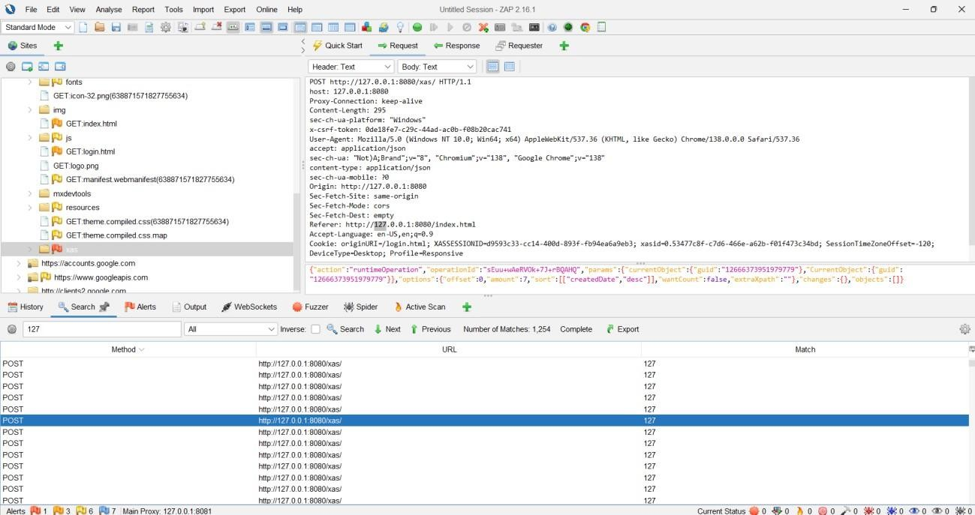

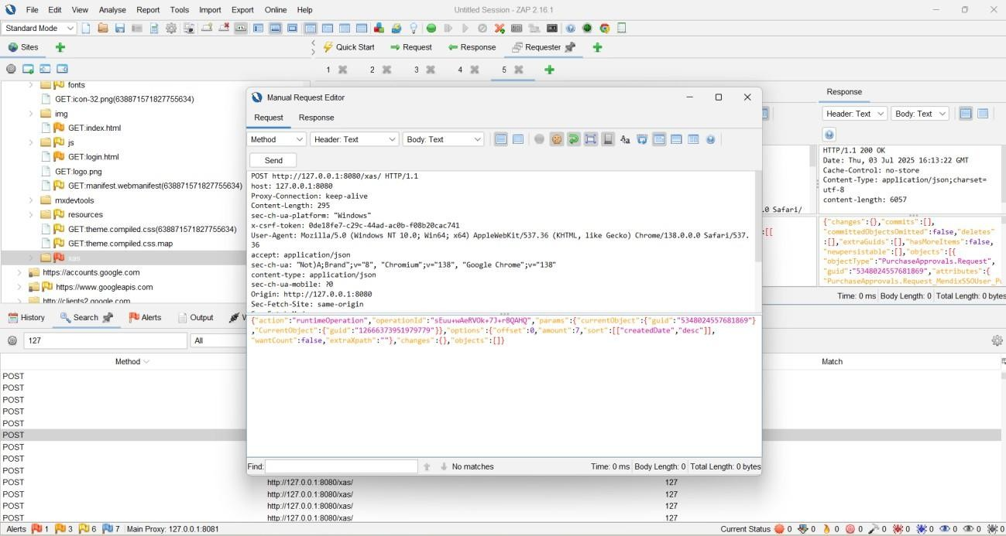

*Fig. 20: Logged-in session and Changed the GUID in Request*

1. **Remove Authentication Headers**
   * Cleared all cookies and tokens in ZAP’s Manual Request Editor.
2. **Send Unauthenticated Request**
   * Sent modified request to the server without authentication details.
3. **Analyze Response**
   * Observed 200 OK response with a valid CSRF token.

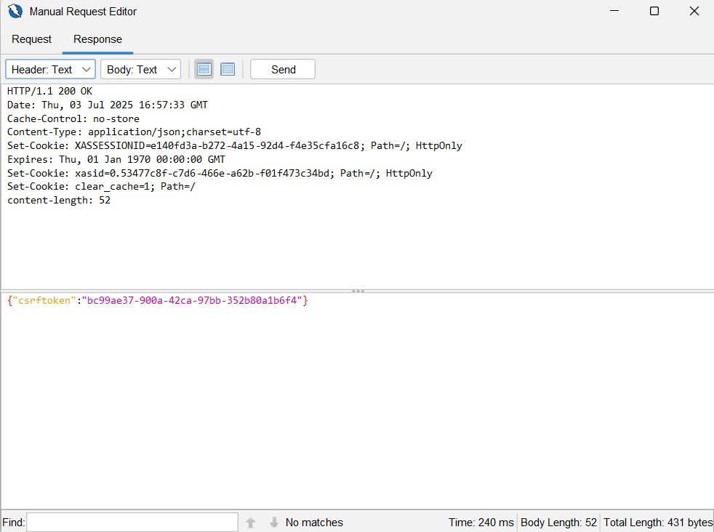

*Fig. 21: Exposed CSRF token*

**Results:**

* /xas/ endpoint was accessible without authentication.
* Expected behavior: 401 Unauthorized or 403 Forbidden.
* Actual behavior: **200 OK with CSRF token exposed**.

**Severity:** Critical (OWASP A01)

**Impact:**

* Allows unauthenticated attackers to retrieve sensitive tokens.

**Recommendation:**

* Enforce authentication and authorization checks for all sensitive API endpoints.
* Ensure unauthenticated requests receive 401/403 and do not expose CSRF tokens.

**Summary Table:**

|  |  |  |  |  |  |
| --- | --- | --- | --- | --- | --- |
| **Endpoint** | **Method** | **Response Code** | **Access Granted?** | **Severity** | **Figure** |
| /xas/ | POST | 200 | Yes | Critical | Fig. 3–4 |

**2.2 Injection Vulnerabilities (OWASP A03: Injection)**

**Objective:**  
To identify potential SQL Injection, XSS, or Command Injection vulnerabilities via OWASP ZAP Active Scan.

**Methodology:**

1. **Target Identification**
   * Proxied authenticated traffic to locate key endpoints.
2. **Active Scan Execution**
   * Ran ZAP Active Scan with payloads for SQLi, XSS, Command Injection.

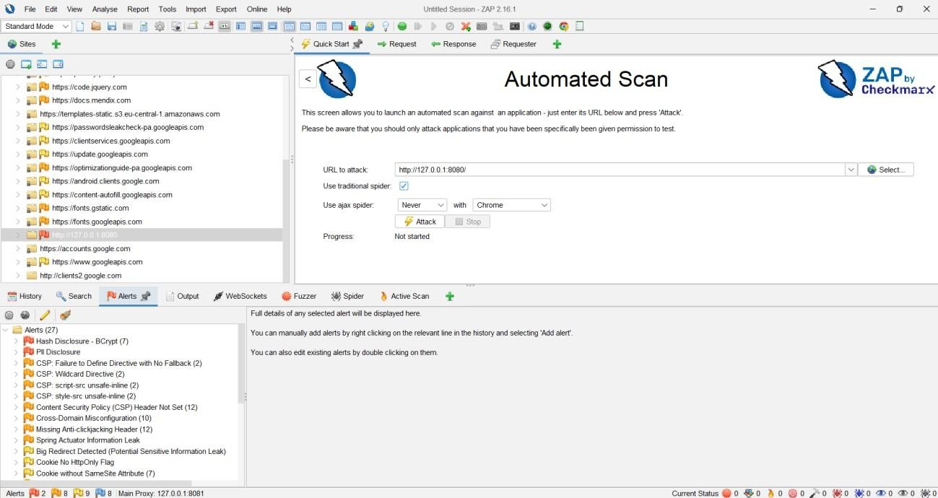

*Fig. 21: ZAP Active Scan Progress Window*

*Shows the progress and configuration of the ZAP Active Scan, confirming coverage of all selected endpoints*

1. **Review Findings**
   * Examined alerts for evidence of injection vulnerabilities.

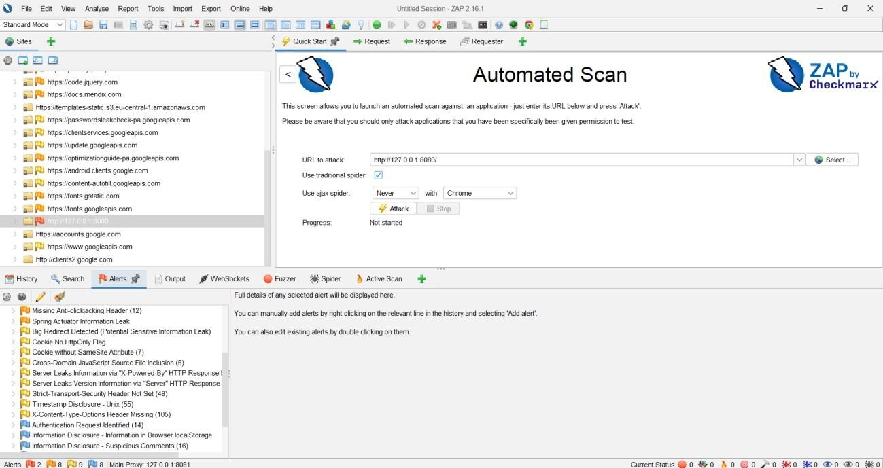

*Fig. 22: No injection detected*

**Results:**

* No SQLi, XSS, or command injection vulnerabilities detected.
* Input fields properly sanitized or blocked.

**Recommendation:**

* Maintain strict input validation.
* Retest after code changes or new features.

**3. Cross-Site Request Forgery (CSRF) Testing (OWASP A05:2021)**

**Objective:**  
To verify presence of CSRF protections (anti-CSRF tokens) for all POST and state-changing requests.

**Methodology:**

1. **Setup & Passive Scan**
   * Logged in, proxied traffic via ZAP, and passively scanned for CSRF patterns.
2. **Manual Review**
   * Inspected POST requests for CSRF tokens.
3. **Analysis of POST Requests**
   * Intercepted /xas/ POST request lacking anti-CSRF token.

**Results:**

* No anti-CSRF tokens found for sensitive endpoints.

**Severity:** Critical (OWASP A05)

**Impact:**

* Attackers could forge authenticated user actions.

**Recommendation:**

* Enforce session-specific CSRF tokens for all POST/PUT/DELETE requests.
* Validate tokens server-side for every request.

**CSRF Analysis Table:**

|  |  |  |  |
| --- | --- | --- | --- |
| Method | URL | CSRF Token Present? | Comment |
| POST | http://127.0.0.1:8080/xas/ | No | Vulnerable to CSRF |

**4. Other Security Issues & Information Disclosure**

**High Risk**

* **Hash Disclosure – BCrypt**: Password hashes exposed at POST /xas/ (7 instances).
* **Impact:** Offline cracking risk.
* **Recommendation:** Never return password hashes in API responses.

**Medium Risk**

1. Missing Content Security Policy (CSP) headers (/, /index.html, /login.html).
2. Missing anti-clickjacking headers (X-Frame-Options, CSP frame-ancestors).
3. Spring Actuator health endpoint exposed (/xas/actuator/health).

**Low Risk**

* Missing HttpOnly & SameSite cookie flags.
* Missing HSTS headers.
* Missing X-Content-Type-Options: nosniff.
* Timestamp leakage in JS files.

**Summary Table:**

|  |  |  |  |
| --- | --- | --- | --- |
| Severity | Vulnerability | Affected Endpoint(s) | Remediation |
| High | Hash Disclosure (BCrypt) | POST /xas/ | Remove hashes from responses |
| Medium | Missing CSP Header | /, /index.html, /login.html | Add Content-Security-Policy header |
| Medium | Anti-clickjacking Header | Main pages | Add X-Frame-Options or CSP |
| Medium | Spring Actuator Leak | /xas/actuator/health | Restrict/disable actuator endpoints |
| Low | Cookie Security Flags | Multiple cookies | Set HttpOnly & SameSite flags |
| Low | HSTS Header Missing | All endpoints | Add HSTS |
| Low | X-Content-Type-Options | Most responses | Add nosniff header |
| Low | Timestamp Disclosure | /dist/*.js | Remove internal timestamps |

**5. Conclusion & Recommendations**

The assessment revealed:

* **Critical vulnerabilities:** Unauthenticated API access, missing CSRF tokens, and password hash exposure.
* **Medium risks:** Missing security headers, actuator leaks.
* **Low risks:** Cookie misconfigurations and information disclosures.

**Immediate Actions:**

* Enforce authentication and CSRF protections.
* Remove sensitive data from API responses.
* Apply missing security headers.
* Restrict internal endpoints.

# Penetration Testing & Vulnerability Assessment Report – Task Tracker

**2.1 Role-Based Access Control (RBAC) Testing**

**Objective**

Assess whether the application enforces proper RBAC for Member and Manager roles, ensuring only authorized resources and features are accessible (OWASP A01: Broken Access Control).

**Methodology**

1. Logged in as **Member1**; explored UI and captured accessible features.
2. Ran **OWASP ZAP Spider** for Member1 to enumerate URLs.
3. Compiled list of accessible endpoints.
4. Repeated the process for **Manager1**.
5. Compared accessible URLs between both roles.

**Results**

* Both Member1 and Manager1 had **identical access** to all major pages, including:
  + TaskOverview, TaskEdit, TeamOverview, MyAccountViewEdit
  + /xas/ API endpoint
  + All static assets and widgets

**Access Comparison Table:**

|  |  |  |  |
| --- | --- | --- | --- |
| Page/Endpoint | Member1 Access | Manager1 Access | Comment |
| TaskOverview | Yes | Yes | Accessible to both |
| TaskEdit | Yes | Yes | Accessible to both |
| TeamOverview | Yes | Yes | Should be restricted? |
| MyAccountViewEdit | Yes | Yes | Accessible to both |
| /xas/ API | Yes | Yes | Accessible to both |

**Security Analysis**

* **Finding:** RBAC not enforced. Both roles share identical privileges.
* **Risk:** If manager-only features (e.g., TeamOverview) are intended to be restricted, this is a **critical RBAC flaw**.
* **Impact:** Regular users may access or modify managerial data, risking data confidentiality and integrity.

**Conclusion & Recommendations**

* Enforce role-based restrictions on sensitive features.
* Implement **backend authorization checks**, not only frontend logic.
* Retest after remediation to confirm proper RBAC enforcement.

**2.2 Insecure Direct Object Reference (IDOR)**

**Objective**

Evaluate whether users can access or manipulate other users' data by altering object identifiers (GUIDs) in API requests (OWASP A01: Broken Access Control).

**Methodology**

1. Logged in as **Member1** and captured an API request containing GUID.  
   *Fig. – Member1 GUID: 4503599627370897*
2. Retrieved Manager1’s GUID: 4503599627370898.
3. Modified Member1’s request to include Manager1’s GUID.
4. Sent tampered request.

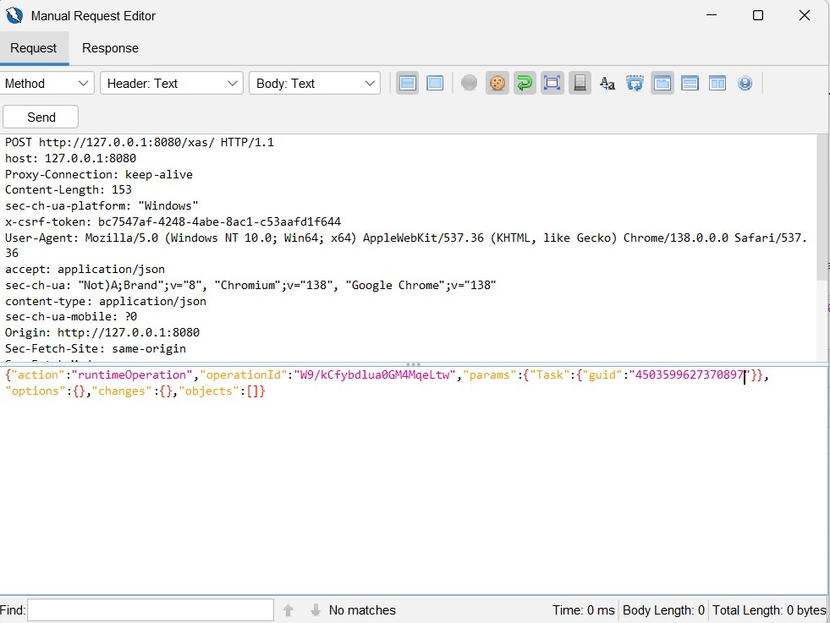

*Fig. 23– Modified GUID request*

1. Analyzed server response.

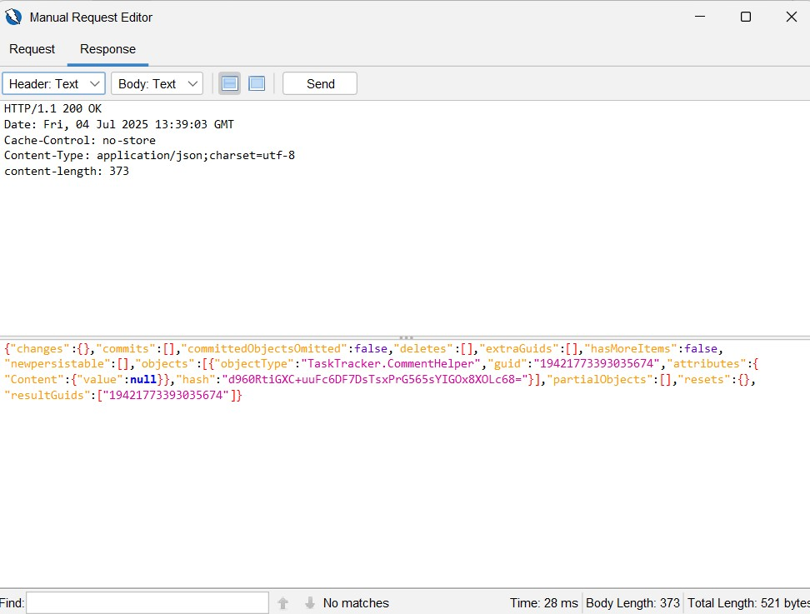

*Fig. 24– 200 OK response*

**Results**

* Server responded with **200 OK** for unauthorized resource access.
* No validation of object ownership occurred.

**Security Analysis**

* **Vulnerability:** IDOR confirmed.
* **Impact:** Unauthorized data access or manipulation.
* **Risk:** Critical (OWASP A01).

**Conclusion & Recommendations**

* Implement **server-side ownership validation** for all object IDs.
* Do not rely on user-supplied IDs for authorization.
* Conduct **regular IDOR testing** after code changes.

**3. API Security & Input Validation**

**3.1 Unauthenticated API Access**

**Objective:** Determine if /xas/ API allows unauthenticated access.

**Methodology:**

* Captured authenticated request using ZAP.
* Removed all cookies and headers.
* Resent the request.
* Observed response.

**Results:**

* Response: 401 Unauthorized.
* No data or logic exposed.

**Analysis:**

* Endpoint correctly enforces authentication.

**Conclusion & Recommendations:**

* Continue enforcing strict authentication checks.
* Retest after new endpoints or features are deployed.

**3.2 Injection Vulnerabilities**

**Objective:** Detect SQL Injection, XSS, and Command Injection vulnerabilities.

**Methodology:**

* Ran **OWASP ZAP Active Scan** on user-input endpoints.
* Reviewed alerts.

**Results:**

* No high or medium severity injection flaws detected.

**Conclusion & Recommendations:**

* Maintain **input sanitization and validation**.
* Retest periodically.

**4. Cross-Site Request Forgery (CSRF)**

**Objective**

Assess presence of anti-CSRF tokens for critical state-changing requests.

**Methodology**

* Passive scan during normal user activity (Member & Manager roles).
* Checked POST/PUT/DELETE requests for CSRF tokens.

**Results**

* **No anti-CSRF tokens present.**
* Critical endpoints unprotected.

**Security Analysis**

* **Vulnerability:** CSRF risk confirmed.
* **Risk:** High – enables unauthorized actions via forged requests.

**Conclusion & Recommendations**

* Implement **unique CSRF tokens** for all state-changing requests.
* Validate server-side.

**5. Other Vulnerabilities (Active Scan)**

**High-Risk Findings**

1. **Hash Disclosure – BCrypt**
   * Location: /xas/
   * Risk: Offline password cracking
   * Remediation: Remove hashes from responses
2. **PII Disclosure**
   * Location: /xas/
   * Risk: Identity theft, compliance breach
   * Remediation: Mask/remove sensitive data

**Medium-Risk Findings**

* Missing CSP headers (/, /index.html, /login.html)
* Cross-Domain Misconfiguration (CORS *)
* Missing Anti-Clickjacking Headers
* Spring Actuator Information Leak (/xas/actuator/health)

**Low-Risk Findings**

* Missing HttpOnly/SameSite flags
* Server version disclosure
* Missing HSTS headers
* Timestamp leakage in JS
* Missing X-Content-Type-Options: nosniff

**Summary Table**

|  |  |  |  |
| --- | --- | --- | --- |
| Severity | Issue | Endpoint(s) | Recommendation |
| High | Hash Disclosure | POST /xas/ | Remove hashes from all responses |
| High | PII Disclosure | POST /xas/ | Mask/remove sensitive data |
| Medium | Missing CSP Header | All pages | Add strict CSP headers |
| Medium | CORS Misconfiguration | External resources | Limit allowed origins |
| Medium | Missing Clickjacking Header | All responses | Add X-Frame-Options or CSP |
| Medium | Spring Actuator Leak | /xas/actuator/health | Restrict/disable actuator |
| Low | Cookie Flags Missing | All cookies | Add HttpOnly & SameSite |
| Low | HSTS Not Set | All endpoints | Enforce HSTS |
| Low | Timestamp Disclosure | Static assets, APIs | Remove unnecessary timestamps |
| Low | X-Content-Type-Options | All | Add nosniff header |

**6. Conclusion & Urgent Recommendations**

* Critical vulnerabilities include **RBAC failure, IDOR, missing CSRF tokens, and sensitive data exposure**.
* Medium and low risks involve **misconfigurations and missing headers**.

**Immediate Actions**

1. Remove password hashes & PII from API responses.
2. Implement proper **RBAC & server-side ownership validation**.
3. Add CSRF tokens to all state-changing requests.
4. Enforce security headers: **CSP, HSTS, X-Frame-Options, X-Content-Type-Options**.
5. Restrict actuator endpoints and clean up sensitive information leaks.

# BugBug Analysis Report

**1. Coffee Service App**

**1.1 Authentication Tests**

**A) Valid Login Test**

**Objective:** Verify successful login for Customer (Jack) and Engineer (Bill).  
**Steps:**

1. Navigate to login page.
2. Enter valid credentials for Customer (Jack).
3. Enter valid credentials for Engineer (Bill).
4. Click *Login*.
5. Verify dashboard loads.

**Results:**

* Customer: Login successful, dashboard displayed.
* Engineer: Login successful, dashboard displayed.

**Figures:**

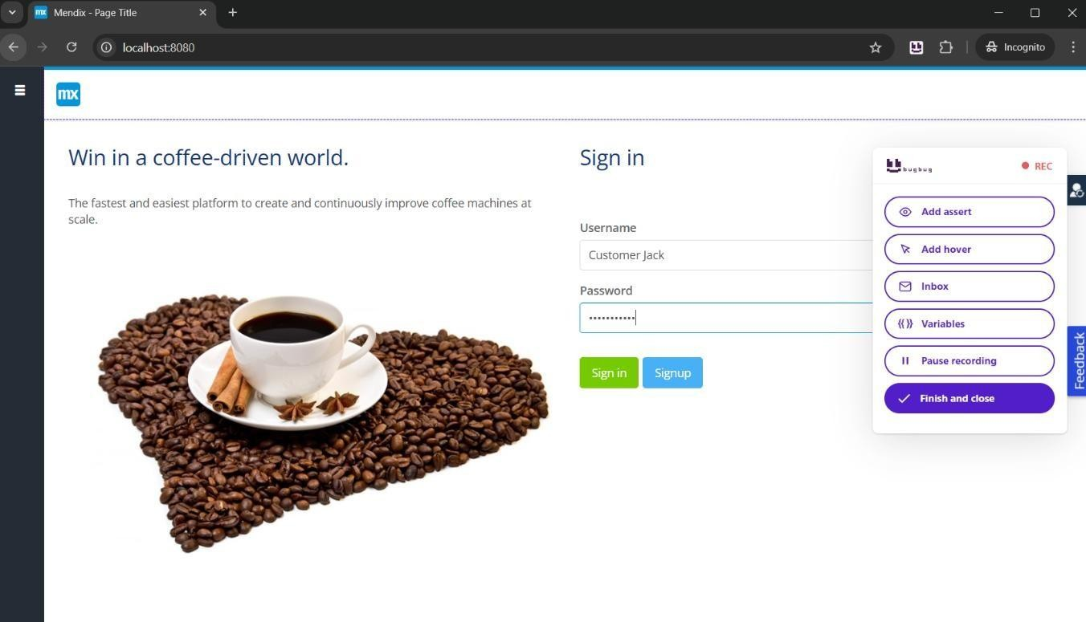

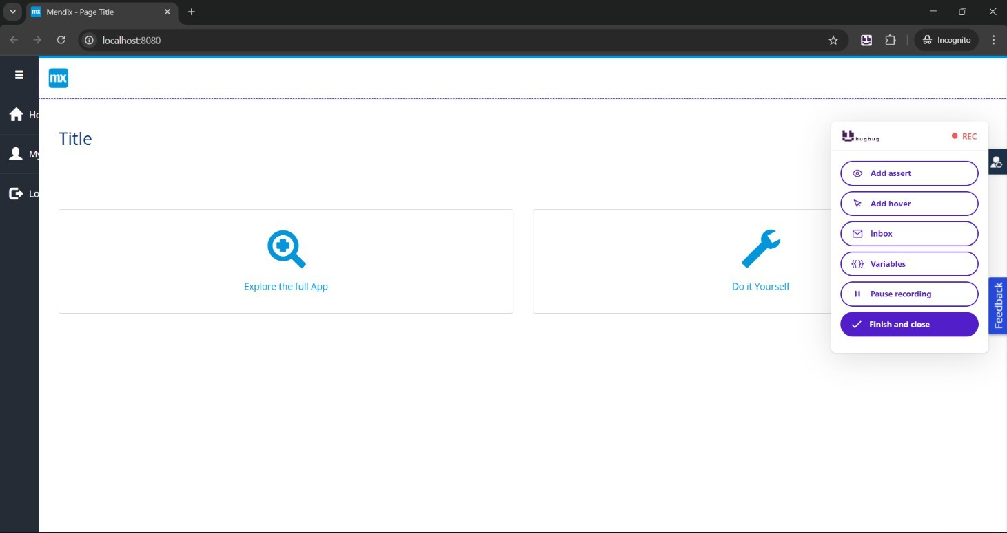

* Fig 1: Logged in as Customer Jack

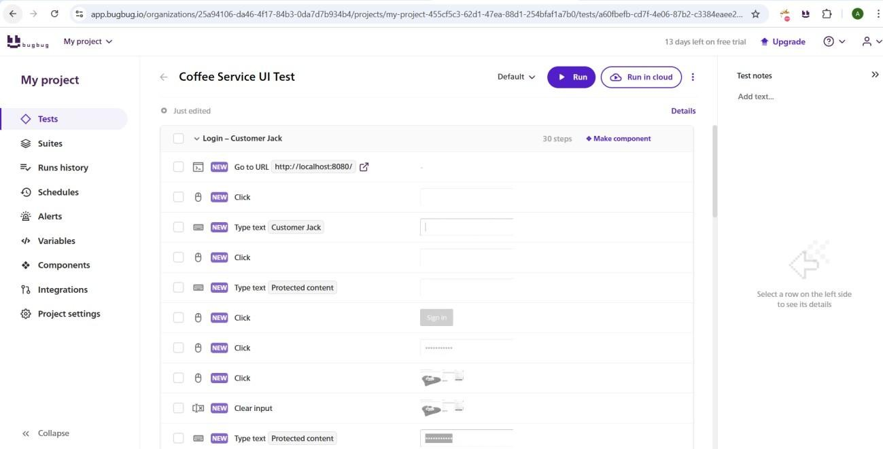

* Fig 2: Dashboard after successful login

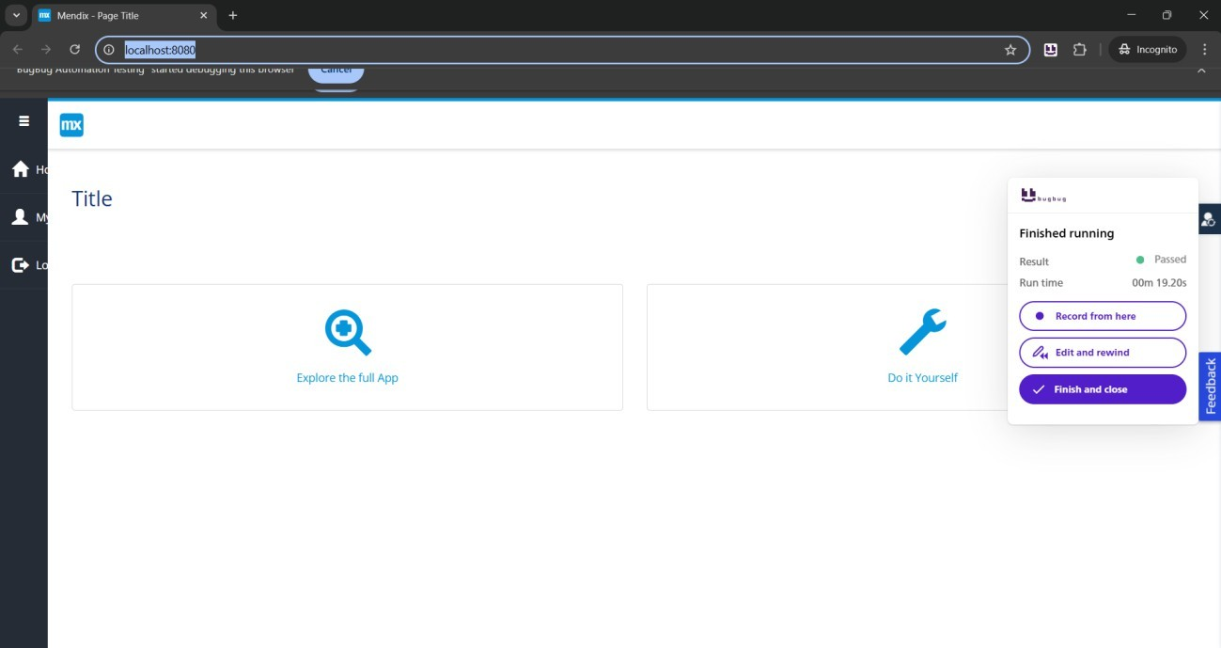

* Fig 3: Login test passed for Customer Jack

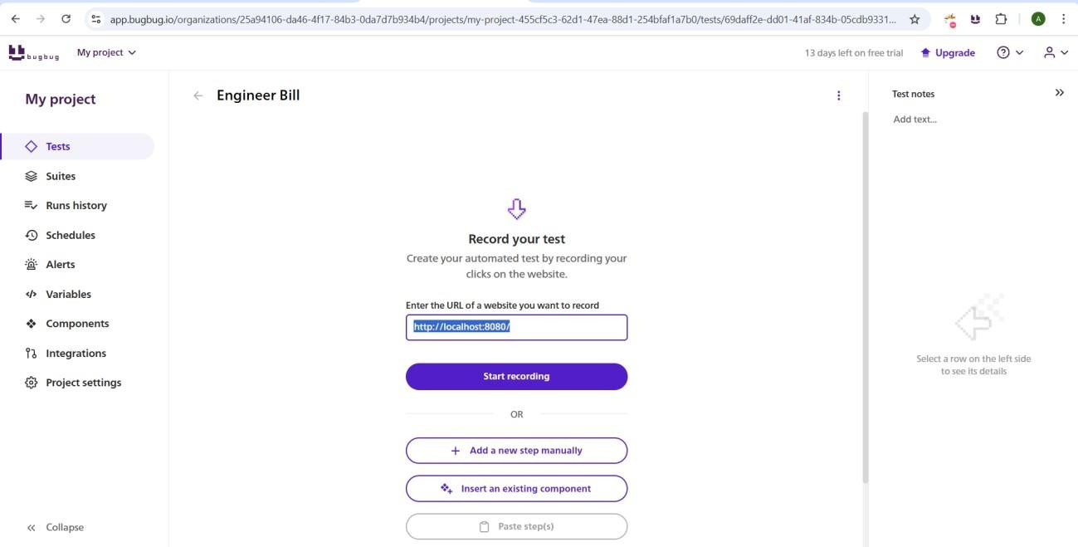

* Fig 4: Starting test for Engineer Bill

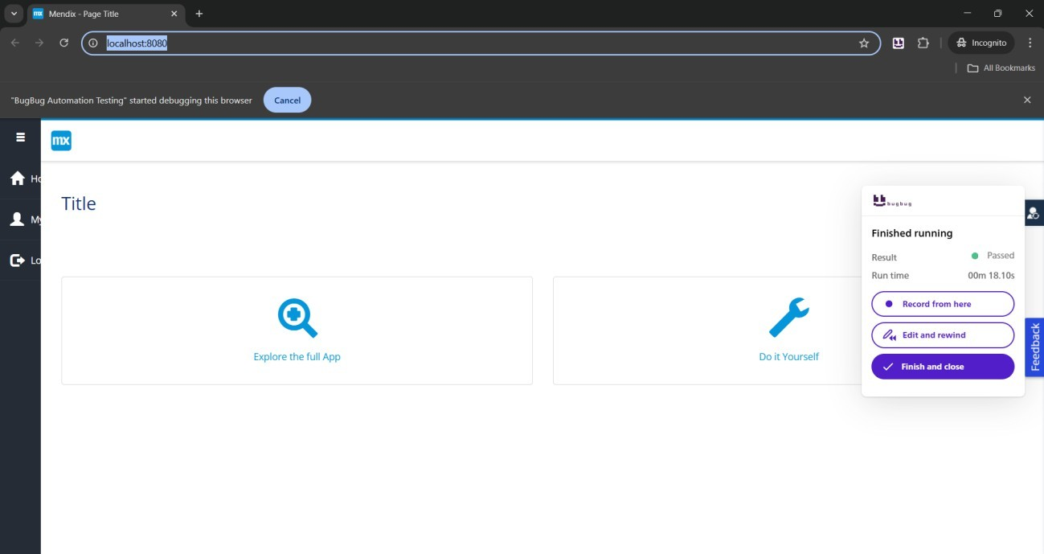

* Fig 5: Login passed for Engineer Bill

**Status:** PASSED  
**Risk:**

* Likelihood: Low
* Impact: High

**Recommendation:** Retest after authentication module updates.

**B) Logout Test**

**Objective:** Verify successful logout for both roles.  
**Steps:**

1. Log in as Customer (Roxanne) and Engineer (Bill).
2. Click *Logout*.
3. Verify redirection to login screen.

**Figures:**

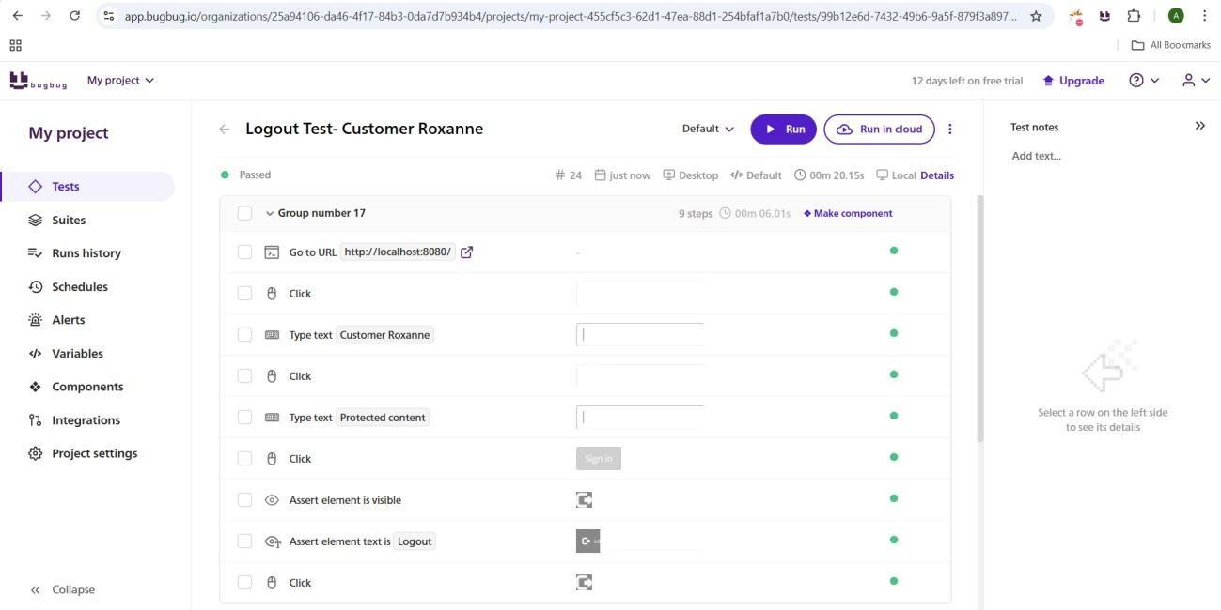

* Fig 6: Logout test passed for Customer Roxanne

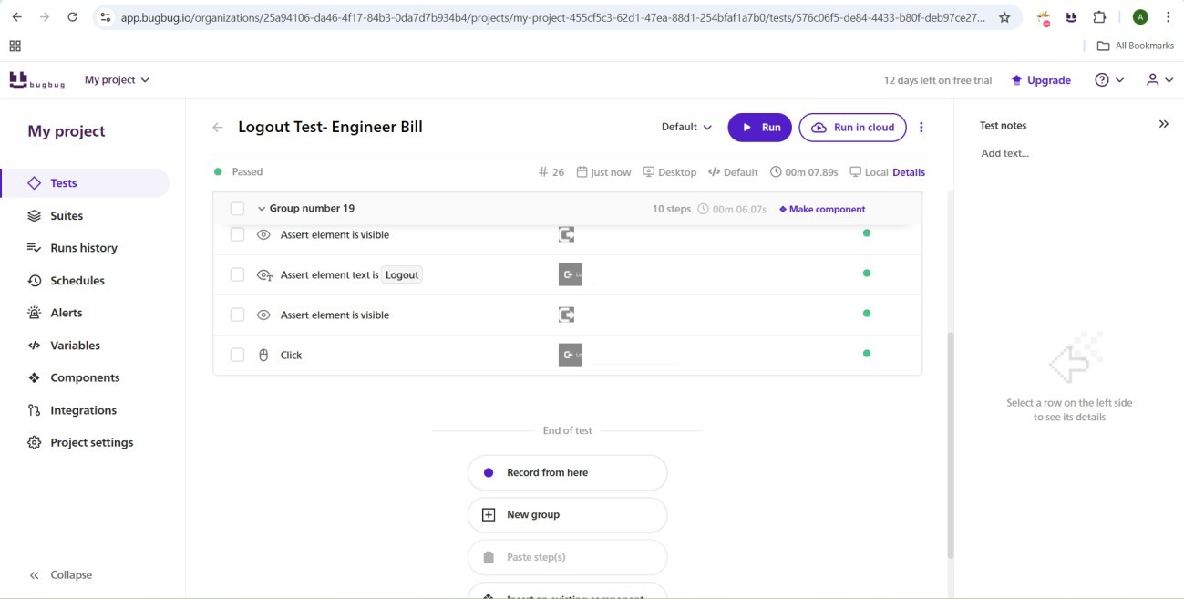

* Fig 7: Logout test passed for Engineer Bill

**Status:** PASSED  
**Risk:**

* Likelihood: Low
* Impact: Moderate

**C) Invalid Login Test**

**Objective:** Verify consistent error messages for invalid credentials.  
**Steps:**

1. Attempt login with incorrect credentials for both roles.
2. Observe error message.

**Results:**

* Customer: Displays “Invalid credentials”.
* Engineer: Displays “Invalid credentials”.

**Figures:**

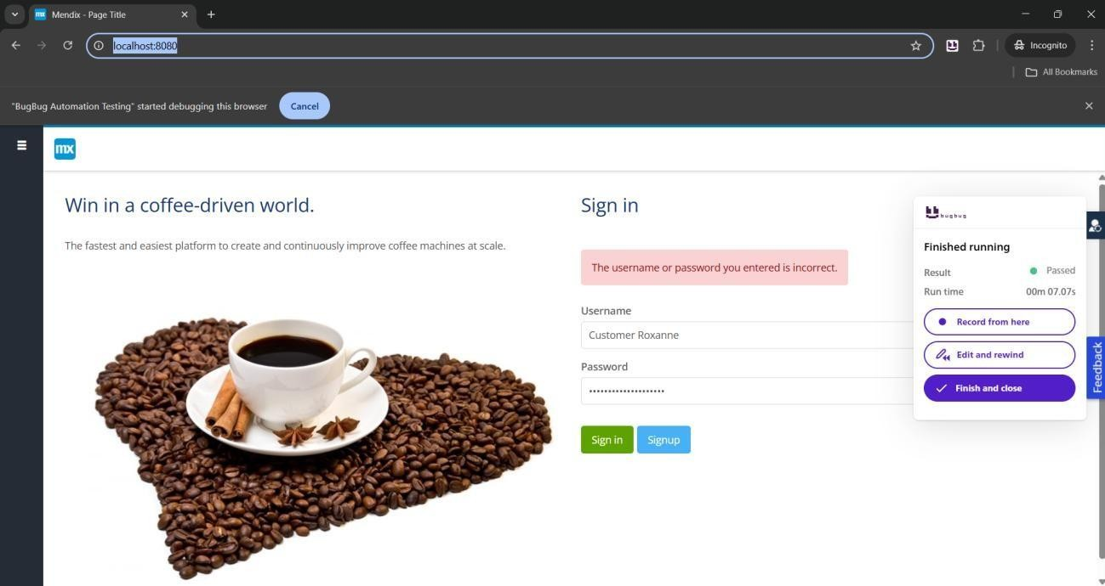

* Fig 8: Invalid login for Customer Roxanne

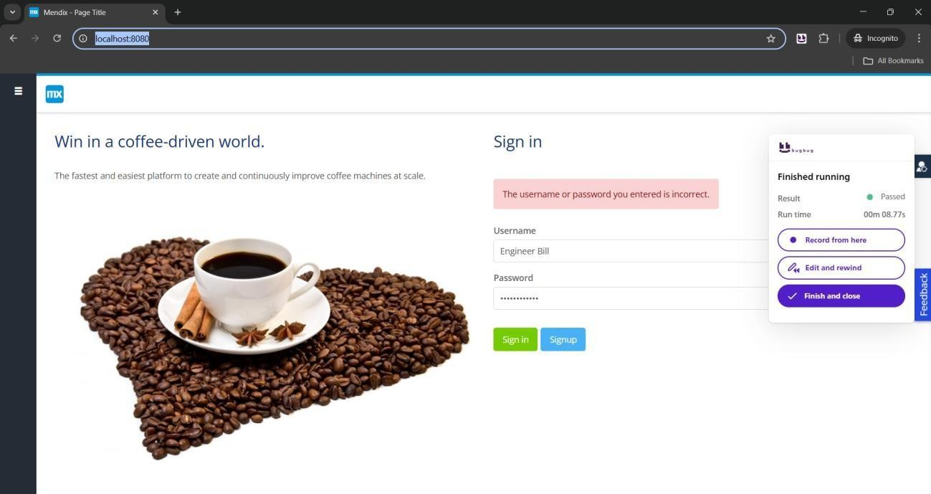

* Fig 9: Invalid login for Engineer Bill

**Status:** PASSED  
**Risk:**

* Likelihood: Low
* Impact: Moderate

**1.2 UI Functional Tests**

**A) Button Click Test**

**Objective:** Verify Save, Cancel, and Next buttons work correctly.  
**Steps:**

1. Click each critical button.
2. Assert expected behavior.

**Figures:**

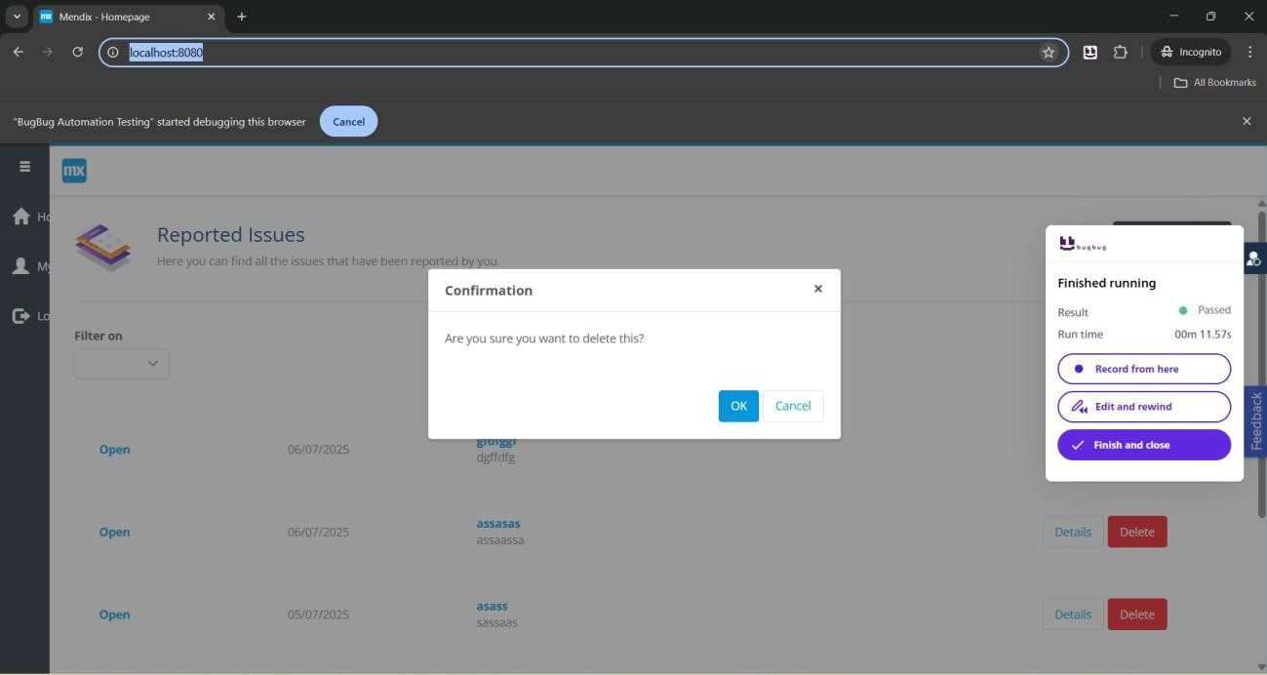

* Fig 10: Button click test passed

**Status:** PASSED  
**Risk:**

* Likelihood: Low
* Impact: Moderate

**1.3 Form Submissions**

**A) Valid Data**

* Forms submitted successfully.
* Confirmation displayed.

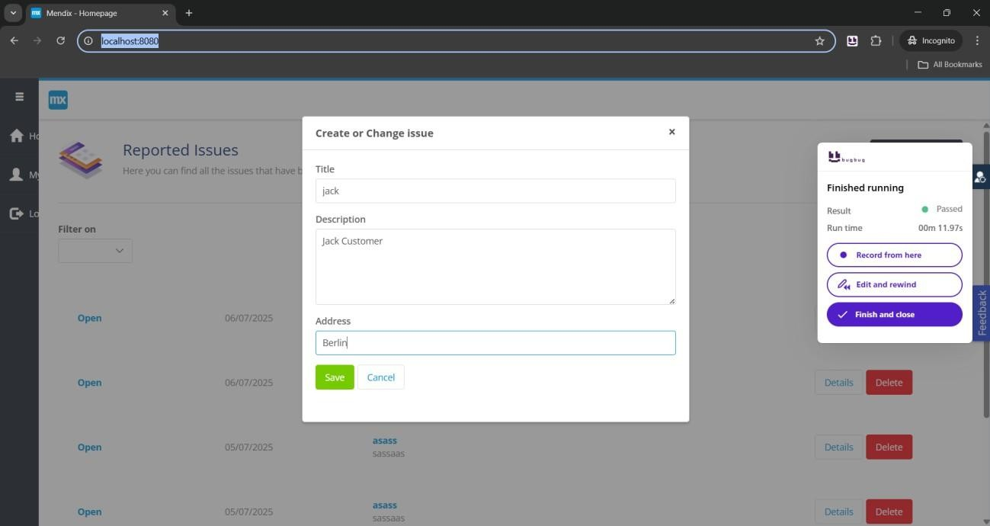

*Fig 10: Valid data test passed*

**Status:** PASSED

**B) Invalid/Missing Data**

* Validation errors displayed correctly.

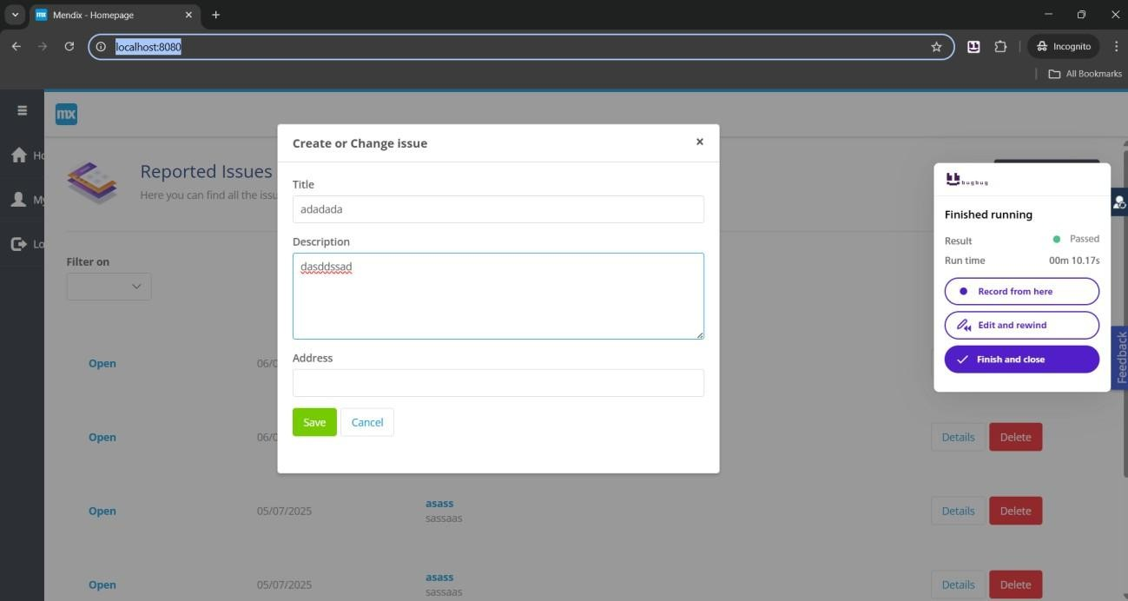

*Fig 11: Invalid data test passed*

**Status:** PASSED

**Risk:**

* Likelihood: Low
* Impact: Moderate

**1.4 Role-Based Access Control (RBAC)**

**Objective:** Verify that Customer, Engineer, Admin, and Manager can only access their authorized features.  
**Results:**

* Unauthorized access attempts were redirected.

**Figures:**

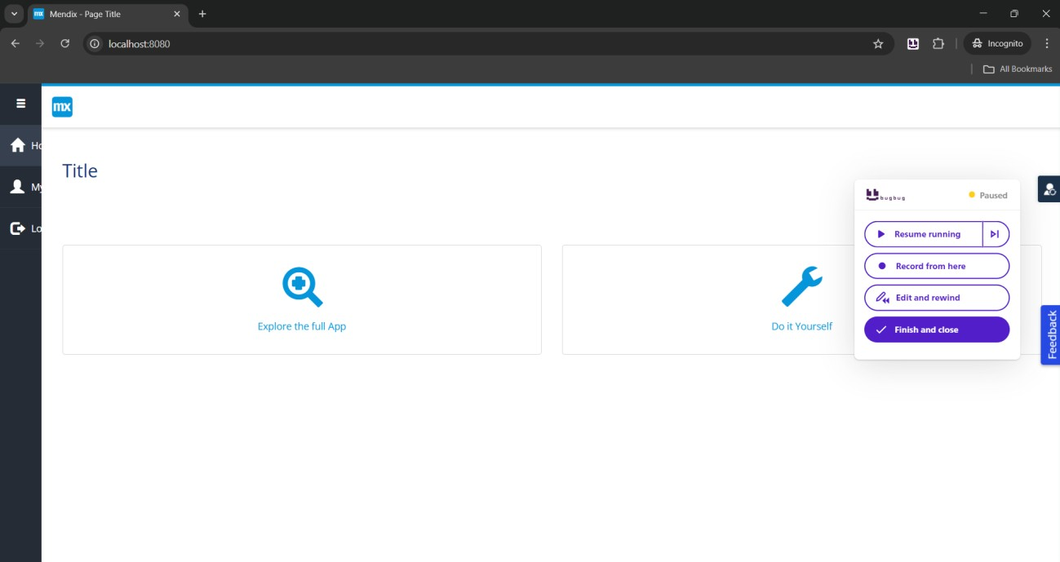

* Logged in as Customer Jack

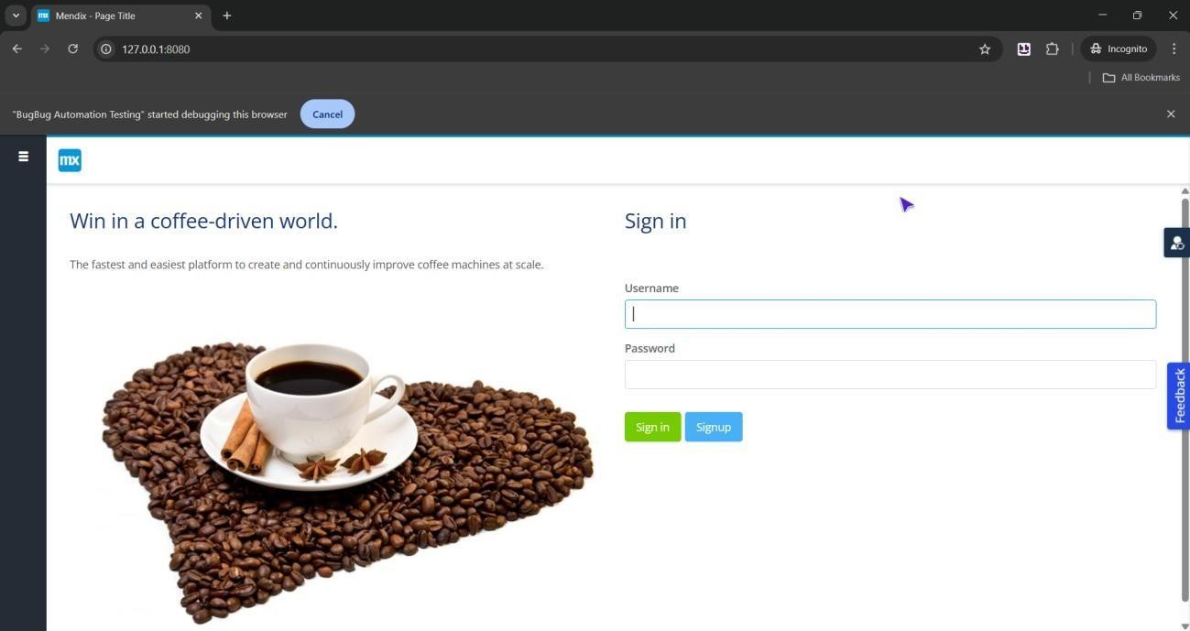

* Attempted Engineer URL <http://127.0.0.1:8080/>

**Status:** PASSED  
**Risk:**

* Likelihood: Low
* Impact: Critical

**1.5 General Recommendations**

* Integrate BugBug tests into CI/CD.
* Expand test coverage regularly.
* Store screenshots/logs for audits.
* Perform manual exploratory testing periodically.

**2. Purchase Request App**

**2.1 Authentication Tests**

**A) Valid Login Test**

**Objective:** Verify successful login for Demo Administrator and Demo Approver.

**Figures:**

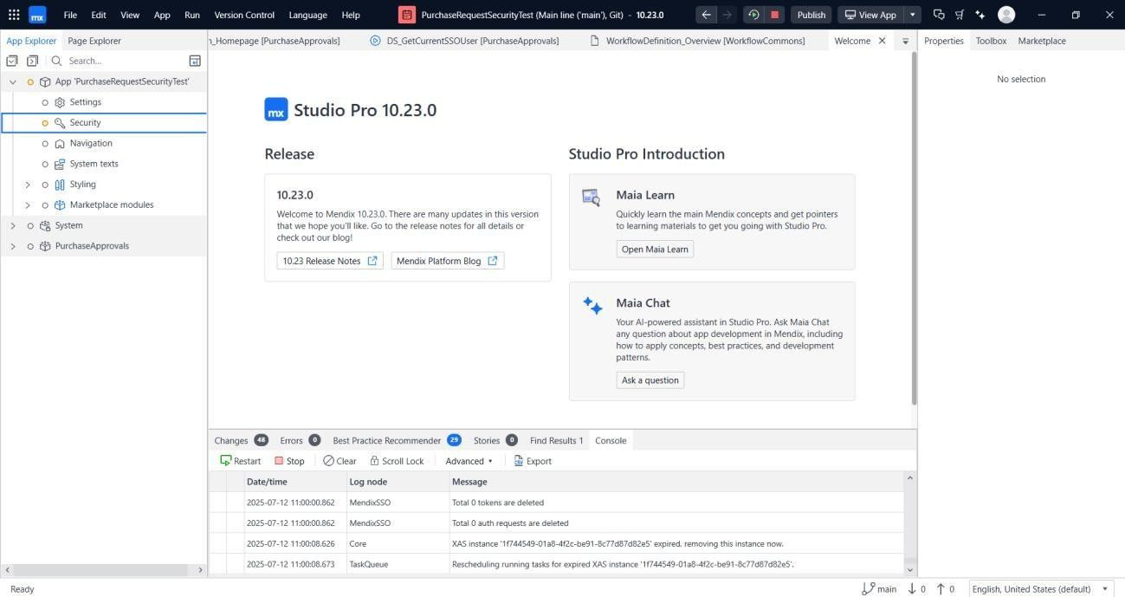

* Fig 1: App started

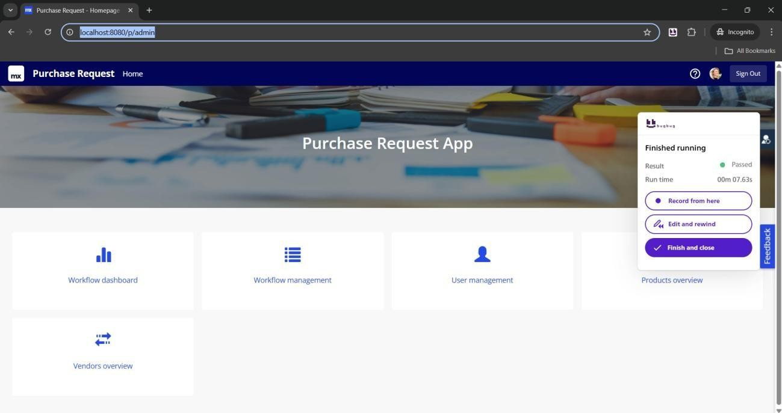



* Fig 2: Signed in as Demo Administrator

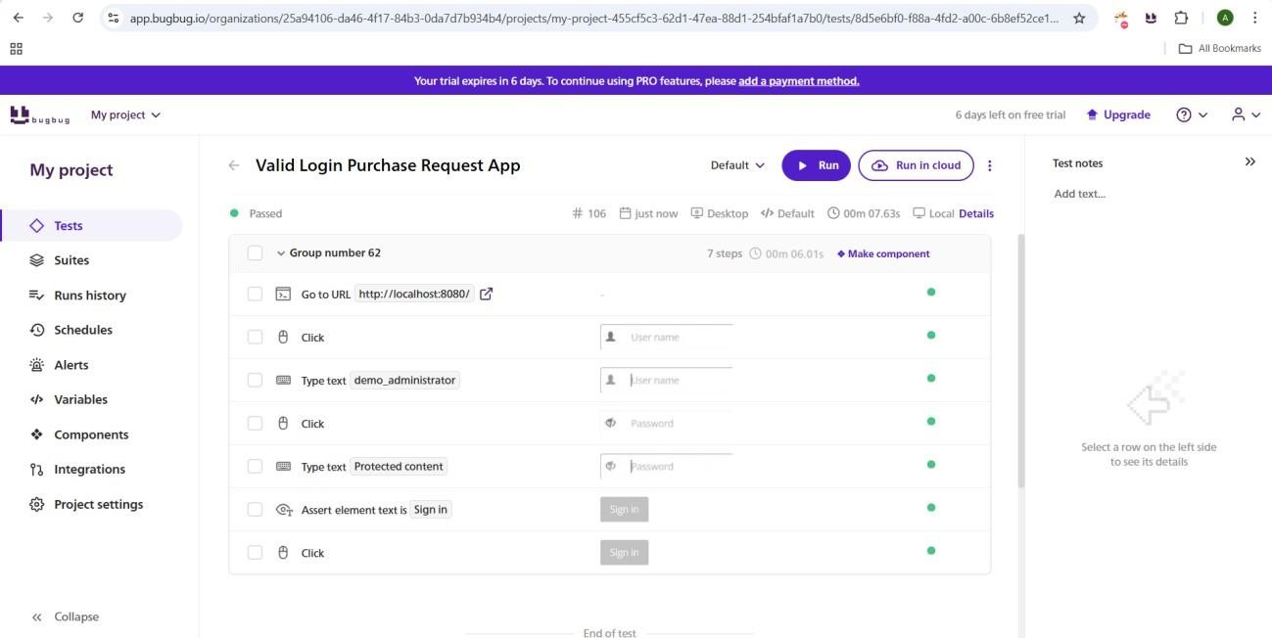

* Fig 3: Assertions – Administrator

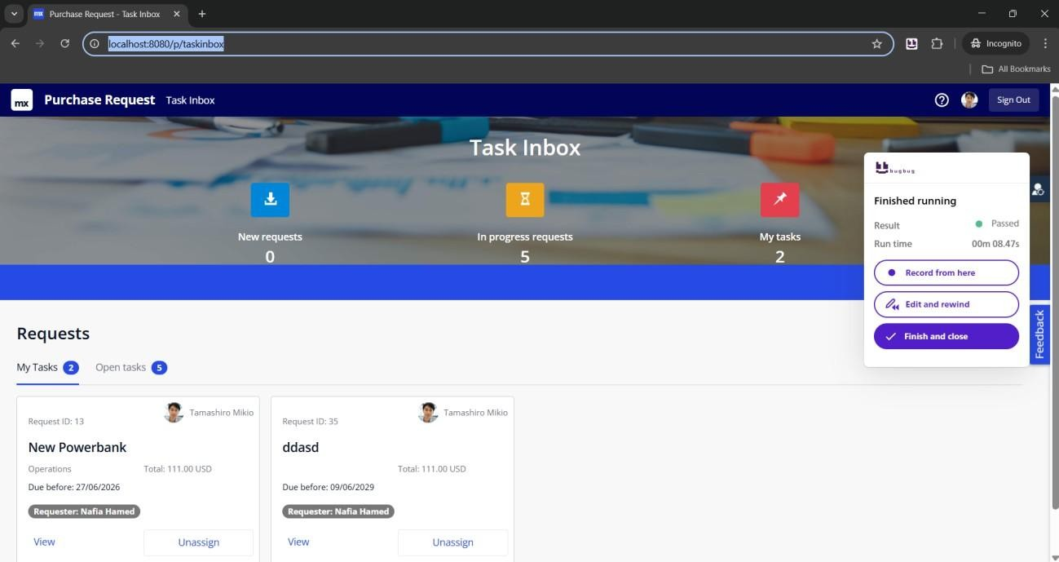

* Fig 4: Login successful – Demo Approver

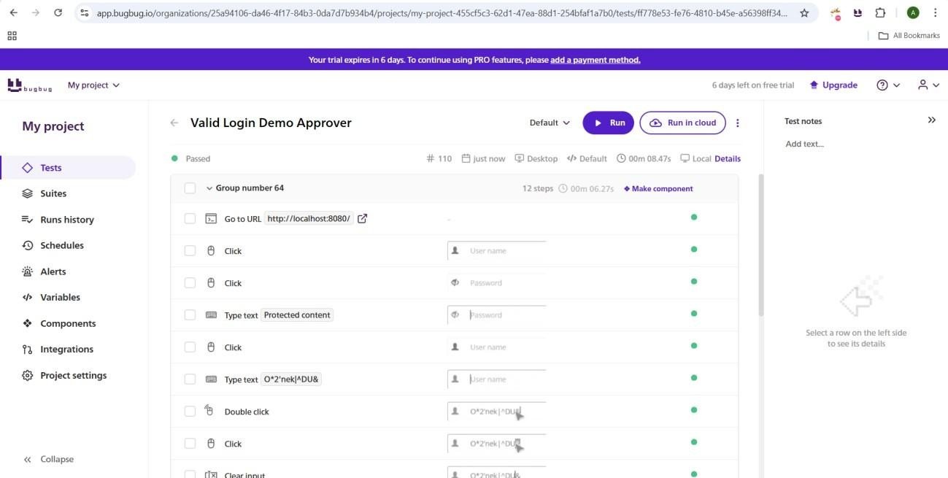

* Fig 5: Assertions – Approver

**Status:** PASSED

**B) Invalid Login Test**

**Objective:** Verify error messages for invalid credentials.

**Figures:**

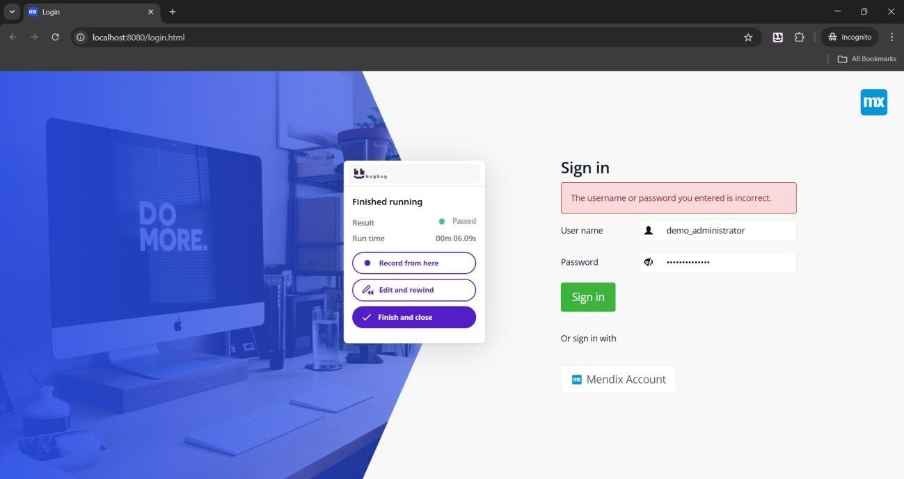

**Invalid login tried with incorrect password on demo administrator**

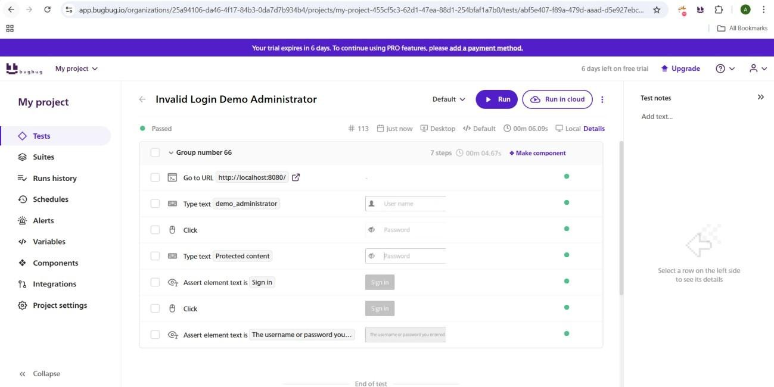

**Assertions Used for Invalid Tests on Demo Administrator**

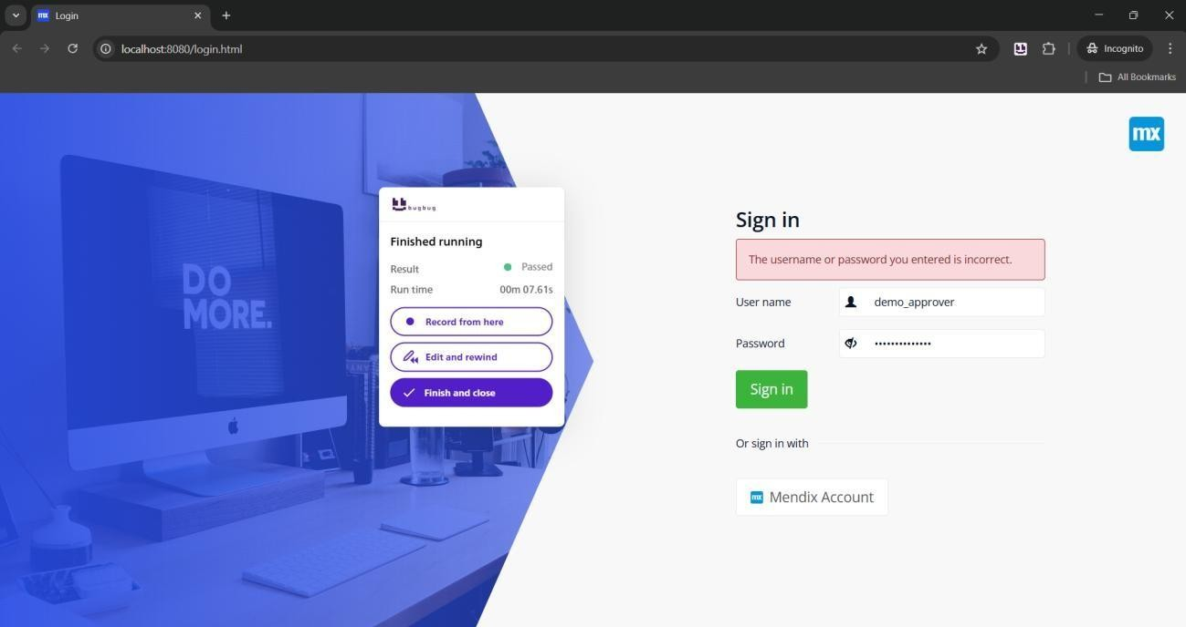

**Invalid login attempted on Demo Approver, Sign in Failed**

* Invalid login attempts

**Status:** PASSED

**C) Logout Test**

**Figures:**

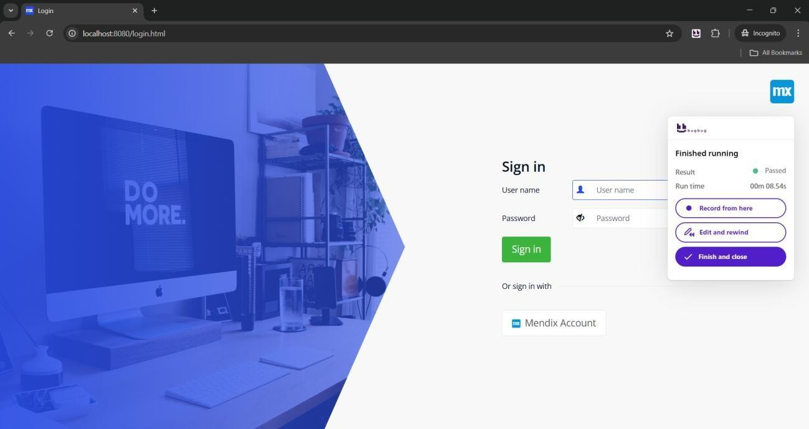

**Sign out was successful for demo administrator**

**Test Objective: Validate successful logout and ensure session termination with no residual access.**

**Steps:**

* **Logout after valid login as Demo Administrator and Demo Approver.**
* **Verify redirection to the login screen.**

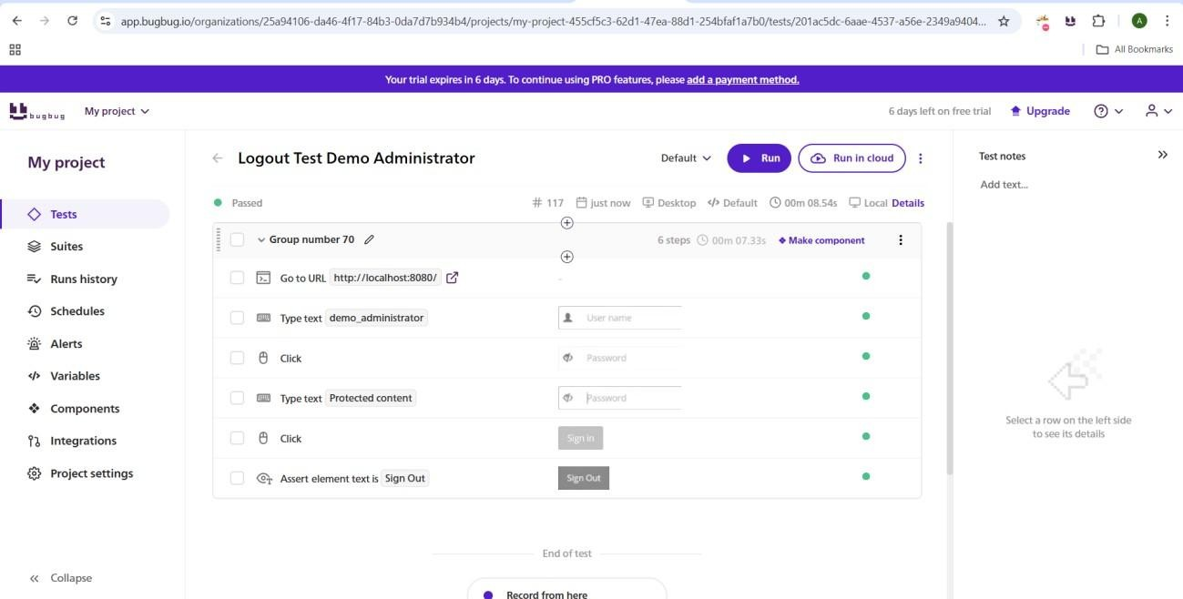

**Assertions used for Demo Administrator**

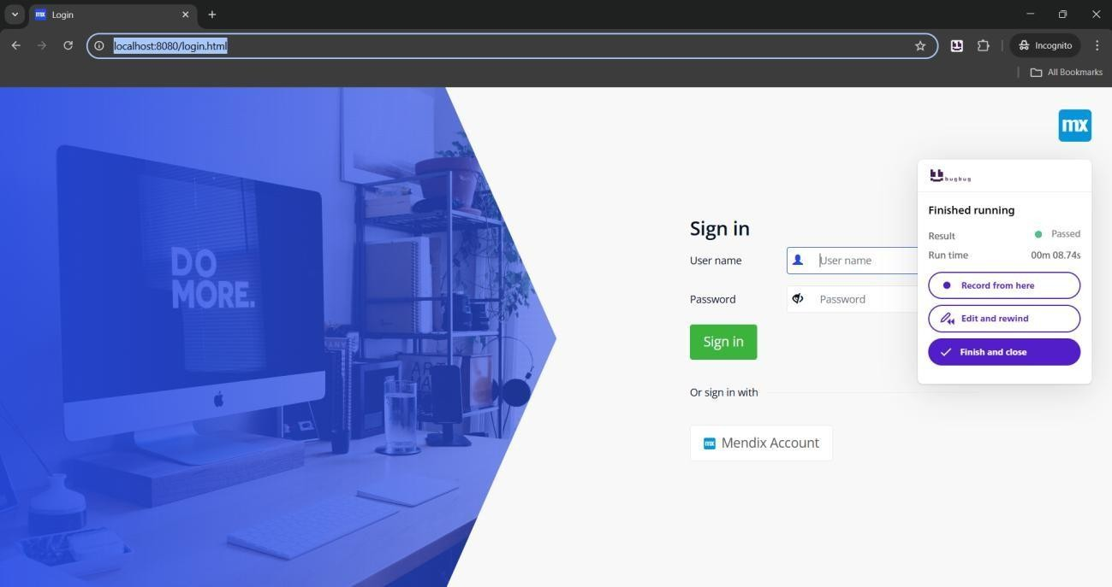

**Sign out Successfully for Demo Approver**

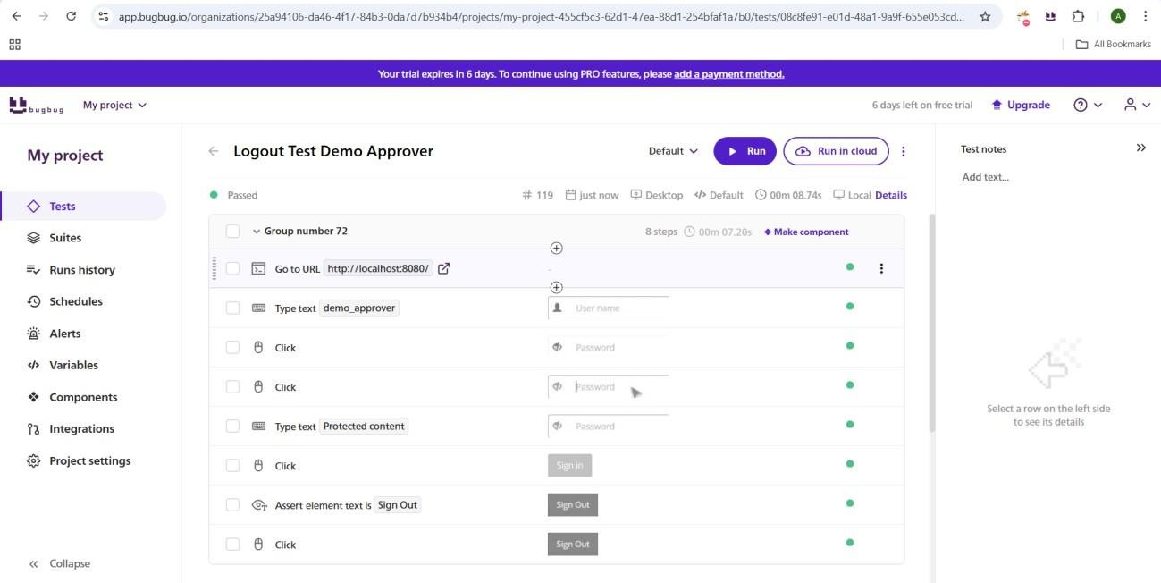

**Assertions Performed on Sign out test Status: PASSED**

**Status:** PASSED

**2.2 UI Functional Tests**

* **Button Clicks:** Passed for Administrator, Approver, Requester.
* **Test Objective: Verify all critical buttons trigger correct behaviors. Steps:**
* **Test Cancel, Save, and other major buttons for all user roles (Administrator, Approver, Requester).**

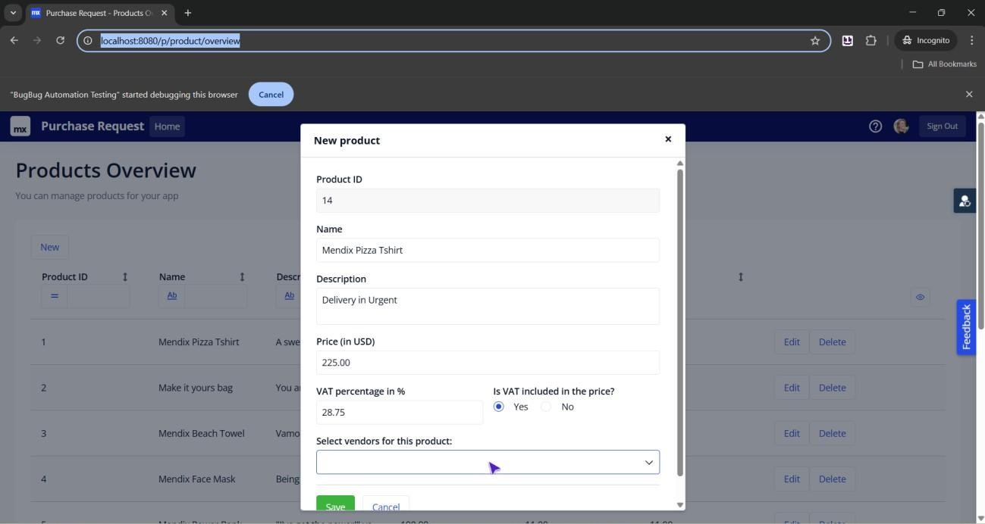

**Figure 13: Running Buton Click Tests and Checking cancel and Save Button Functionality**

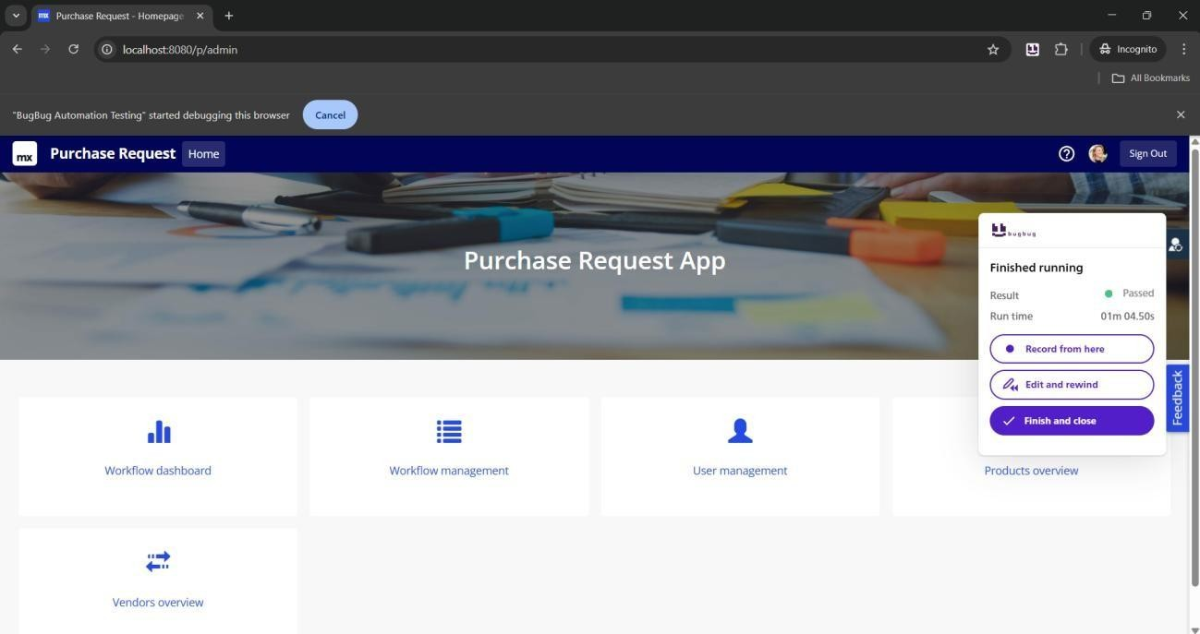

**Button Tests Successfully Passed for Administrator**

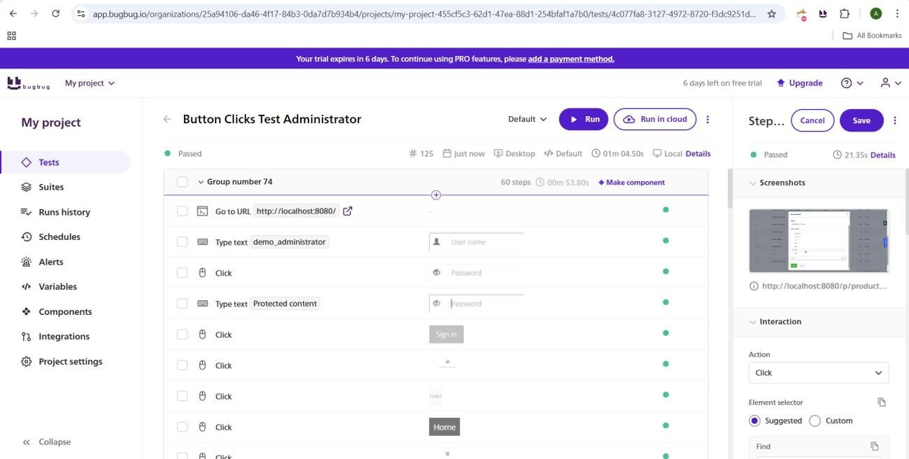

**Assertion used for Button Clicks on Administrator account**

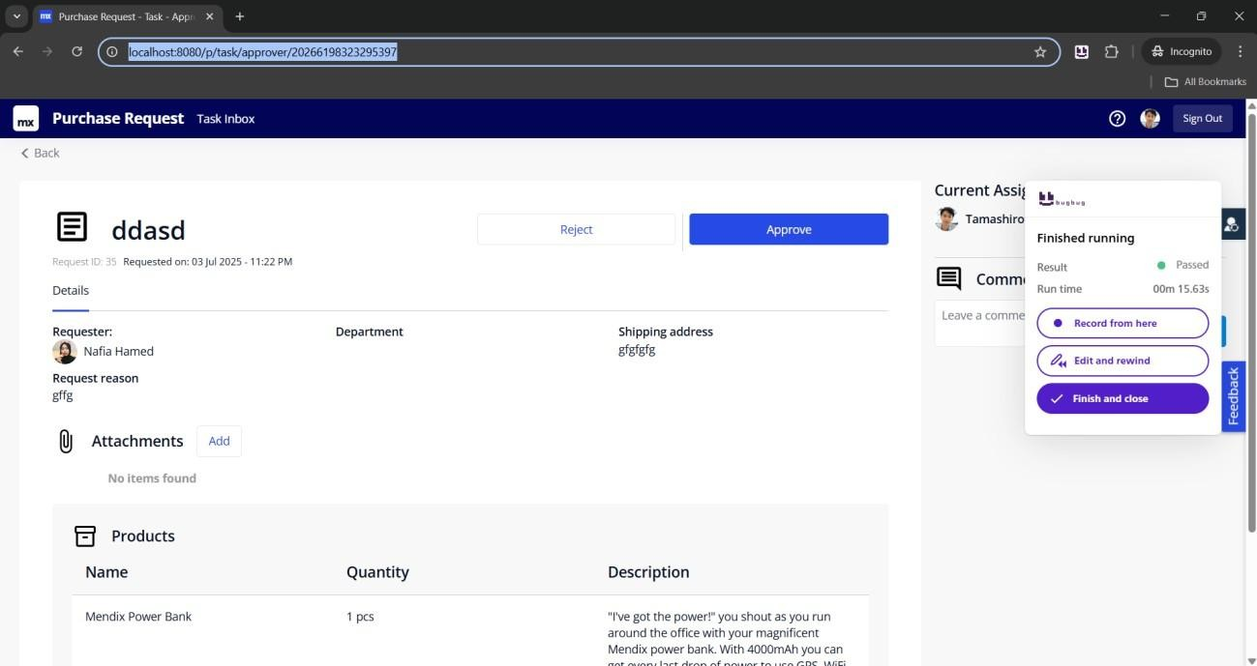**Button Clicks Test Successful on Approver**

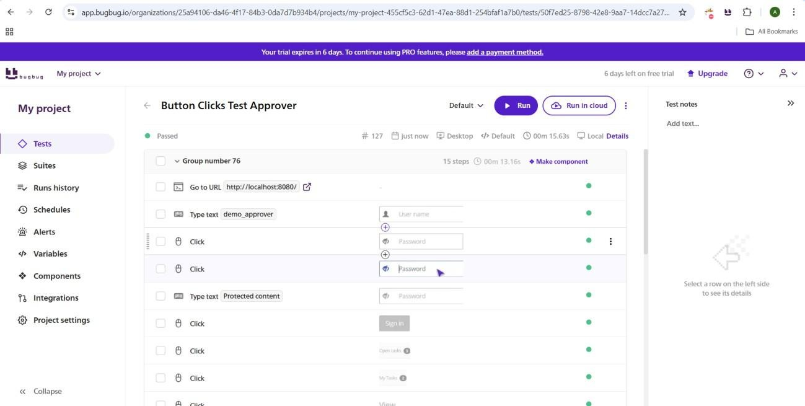

#### Assertions used for Approver

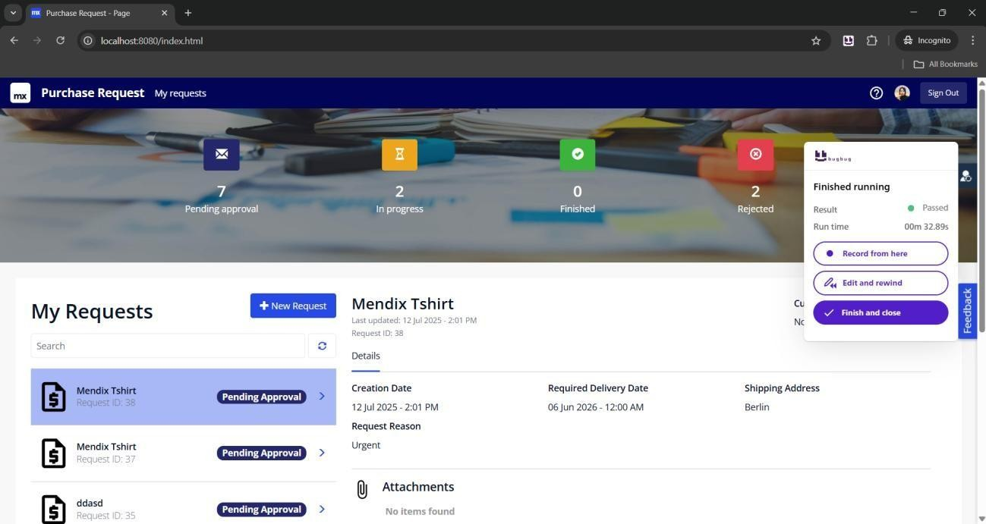

**Button Clicks Test passed for requester user**

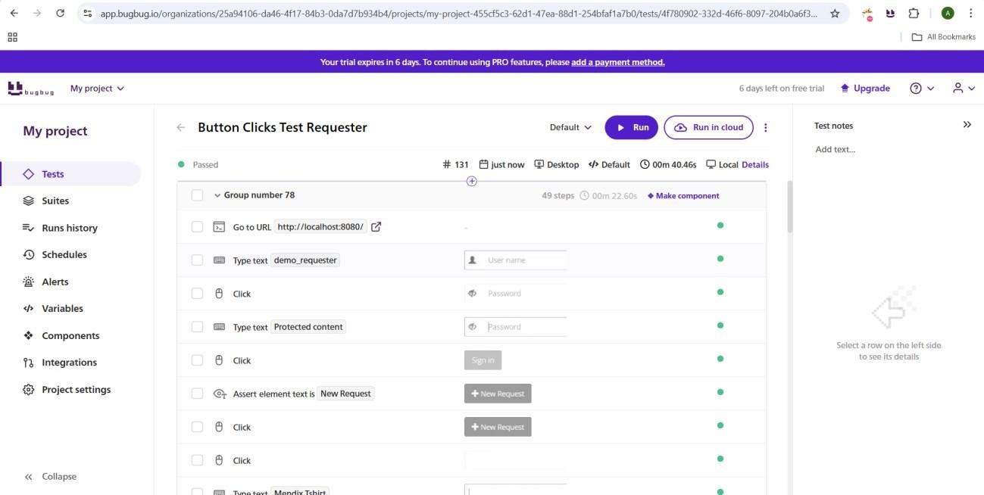

**Assertions used for Requester user**

* **Form Submission (Valid):** Passed
* **Form Submission (Invalid):** Passed

**Risk:** High if validation fails.

**2.3 RBAC Tests**

* Requester could not access Admin features.

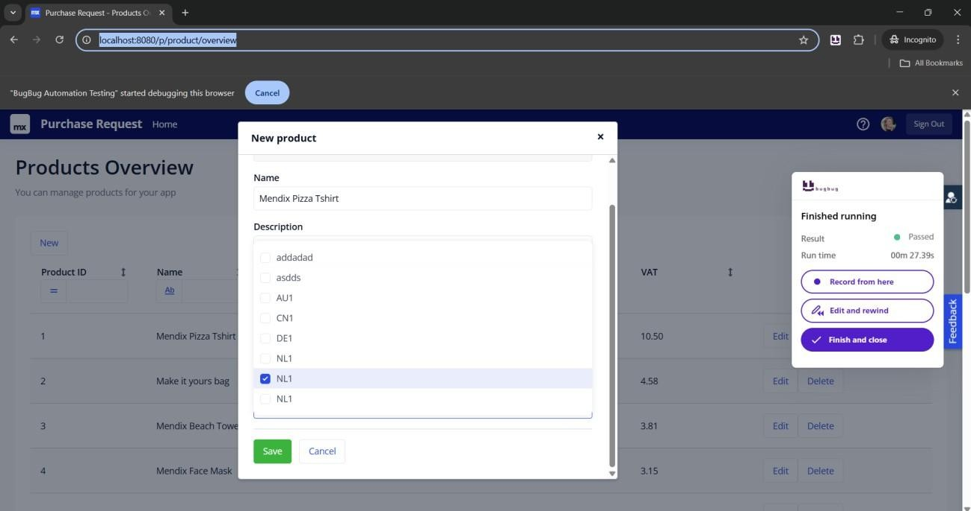

**Form Submission Valid Data Administrator Passed**

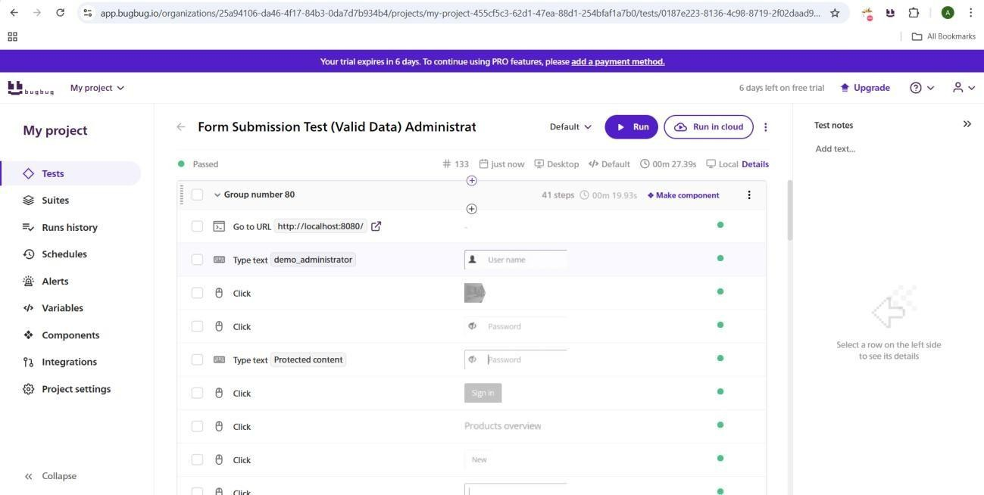

#### Assertions Used

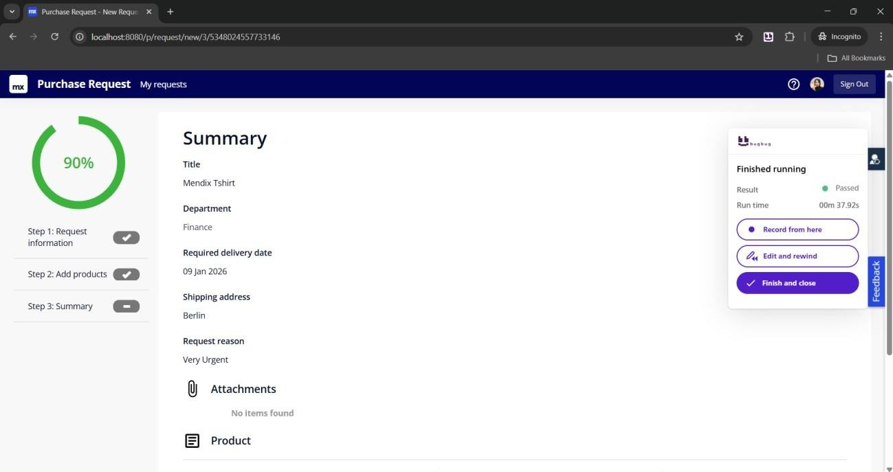

**Form Submission Valid Data Requester Passed**

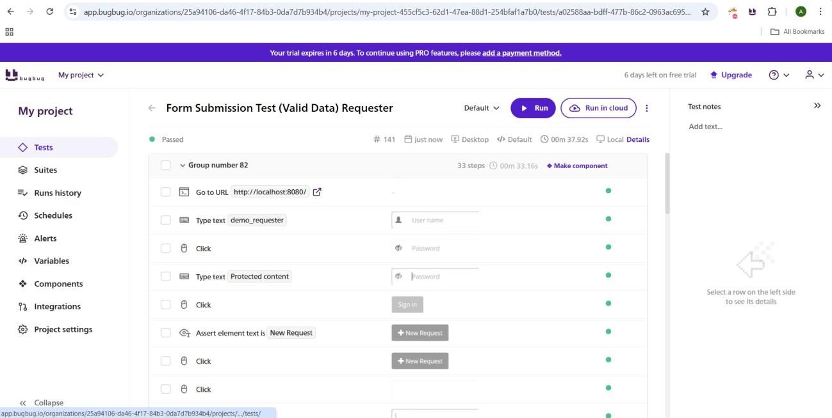

#### Assertions used

**Status: PASSED**

**C) Form Submission Test (Invalid/Missing Data)**

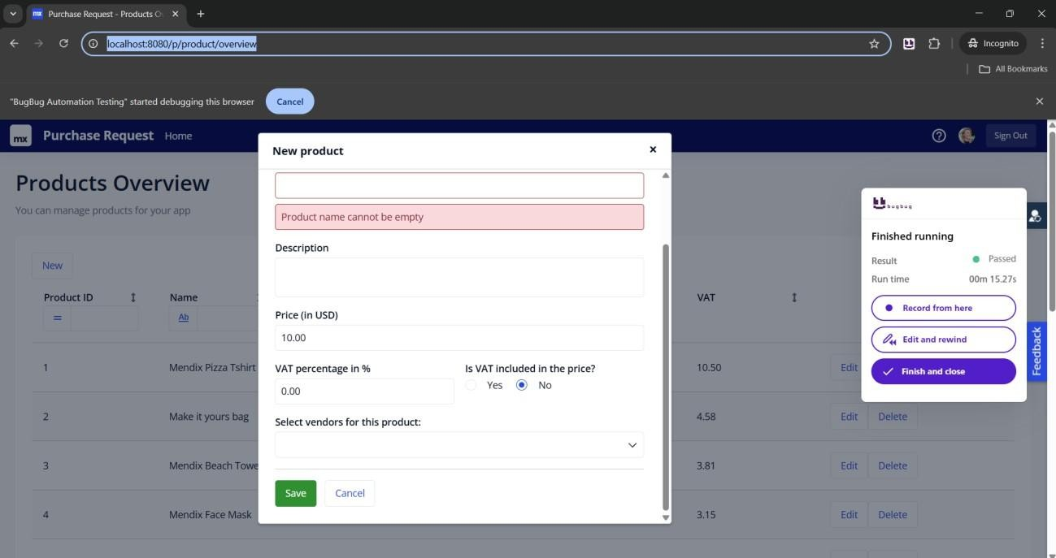

**Shows Error on Admin dashboard for missing data**

**Test Objective: Ensure appropriate validation and error handling for invalid or missing form data.**

**Steps:**

● **Attempt submissions with invalid or missing data.**

**Status:** PASSED

**2.4 Recommendations**

* Implement automated RBAC regression tests.
* Enhance data validation controls.
* Include BugBug automation in CI/CD.

**3. Task Tracker Security App**

**3.1 Authentication Tests**

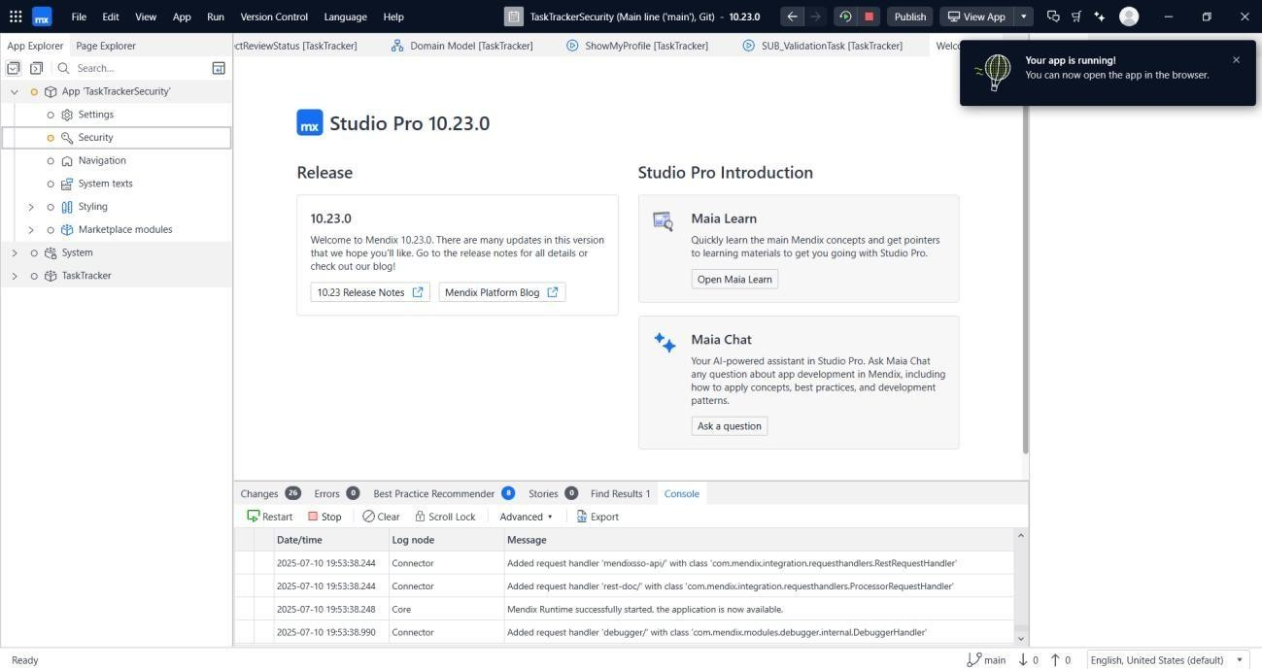

**Successful App Run From Mendix Platform**

**1. Authentication Tests**

**a) Valid Login**

**Test Objective:**

**Ensure that users can log in successfully using valid credentials and access appropriate role-specific dashboards.**

**Steps:**

* **Log in as Manager1 (Manager role)**
* **Log in as Member1 (Member role)**
* **Confirm correct dashboard and access privileges**

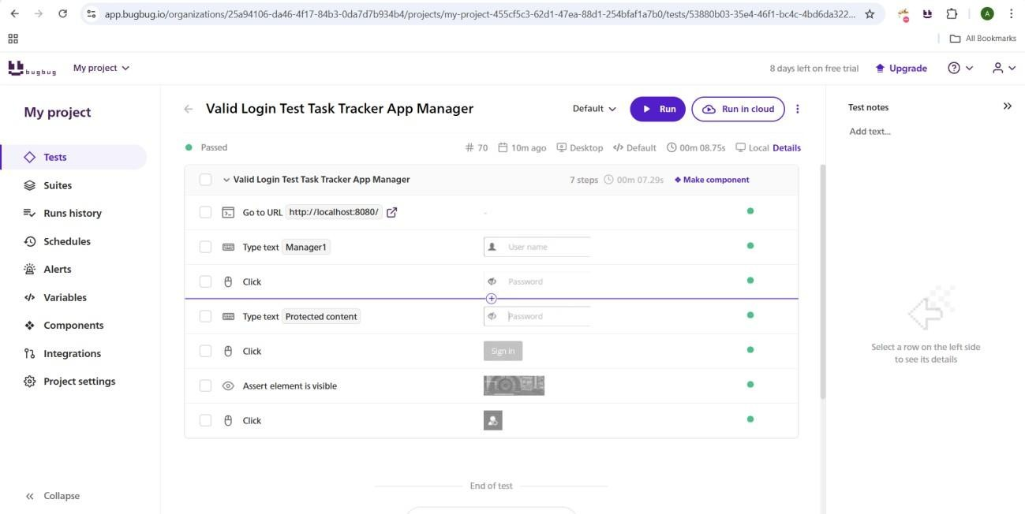

#### Assertions Performed

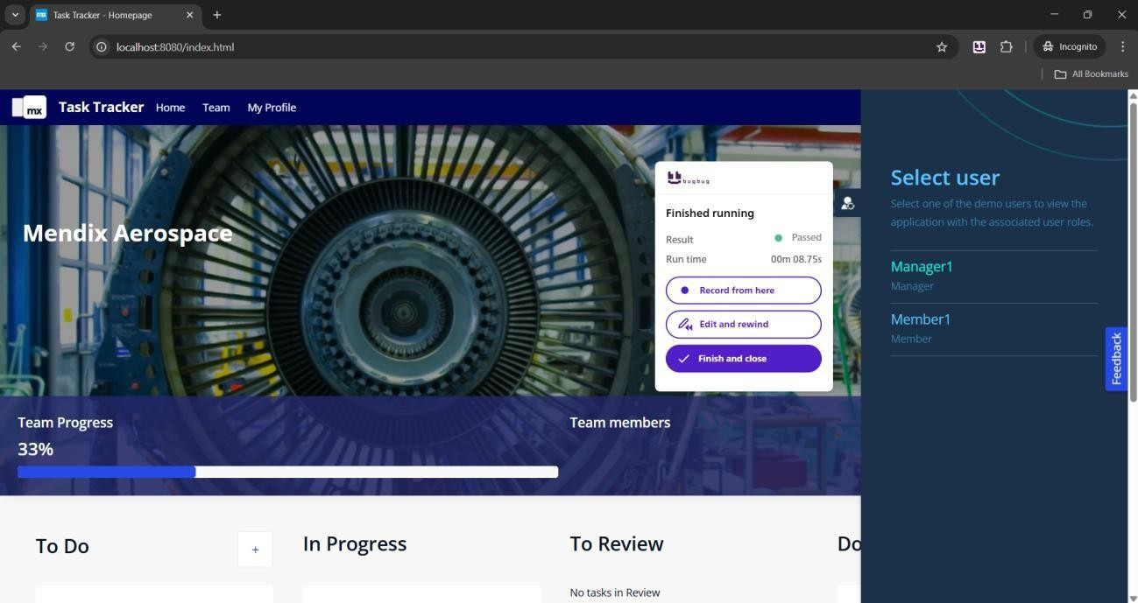

#### Tests Passed

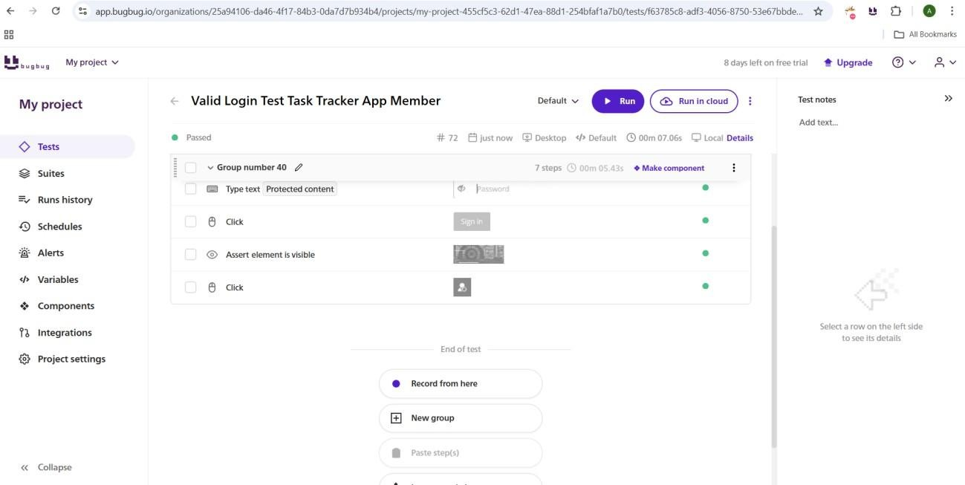

Test Assertions for Member

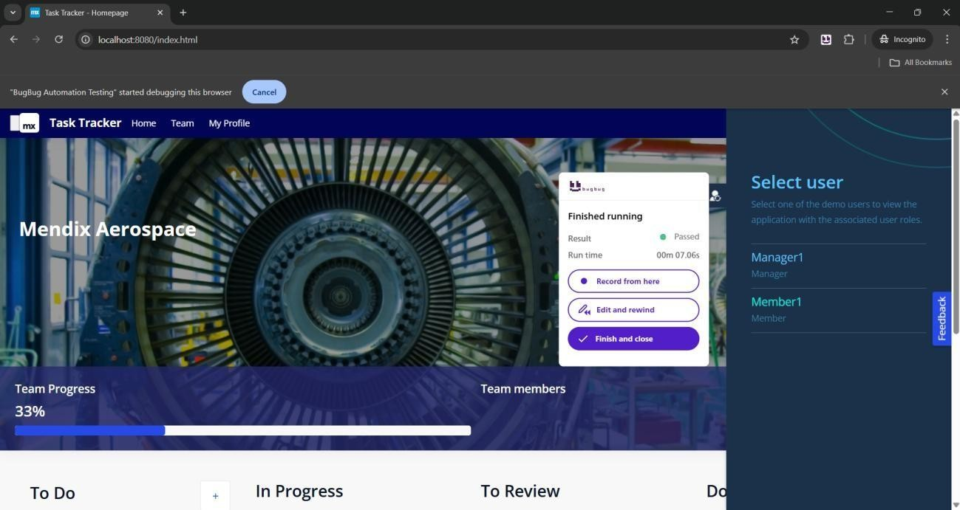

#### Fig 5: Test Passed for member login

* **Valid Login:** Manager1 & Member1 – PASSED.
* **Invalid Login:** Error messages consistent – PASSED.
* **Logout:** Successful – PASSED.

**3.2 UI Functional Tests**

* Button clicks – PASSED.
* Form submissions:
  + Valid – PASSED

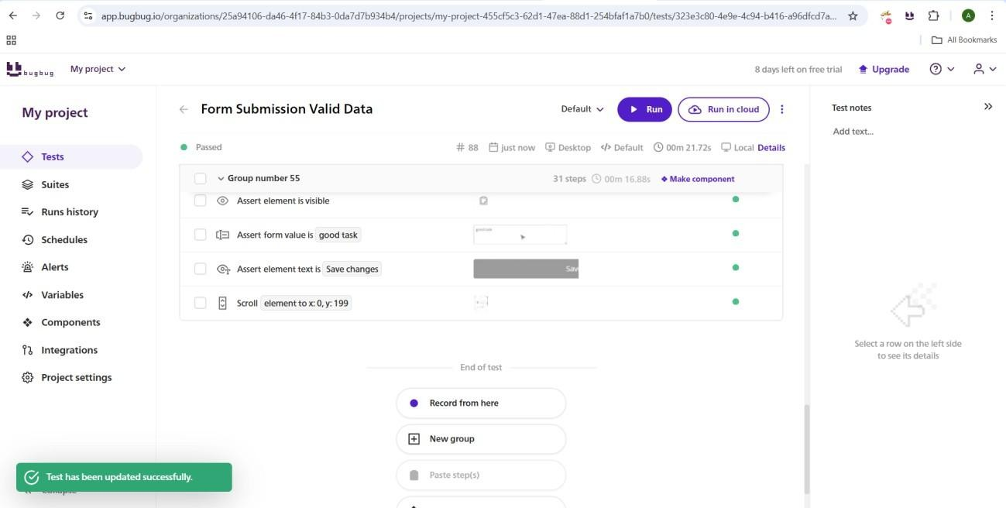

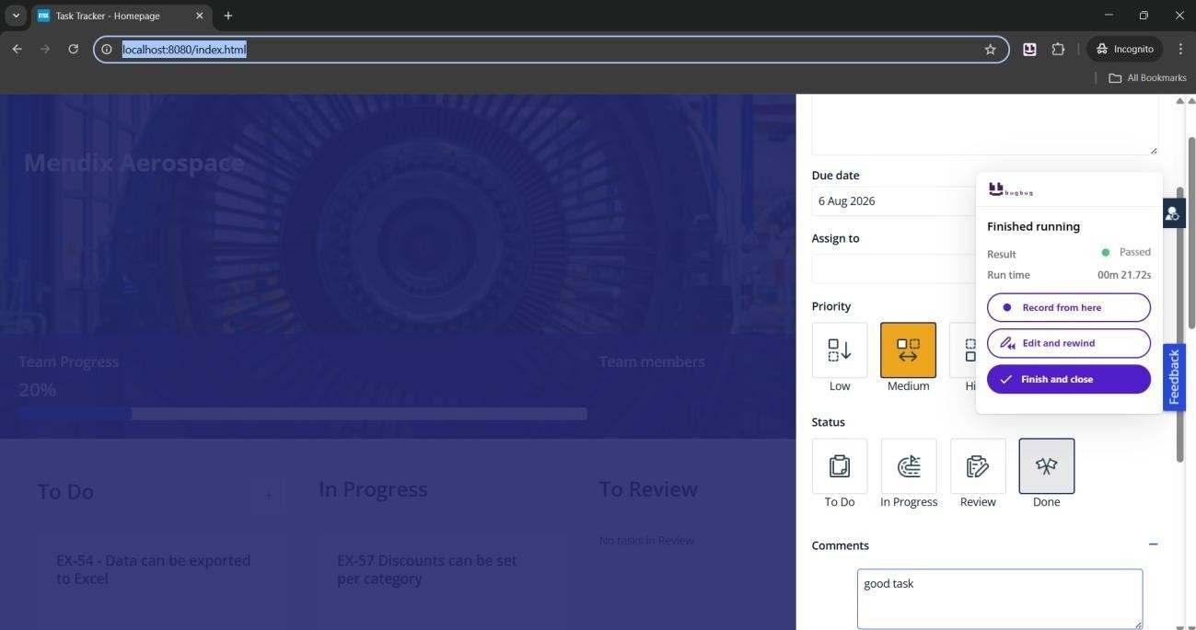

* + Invalid – PASSED

**3.3 RBAC Tests**

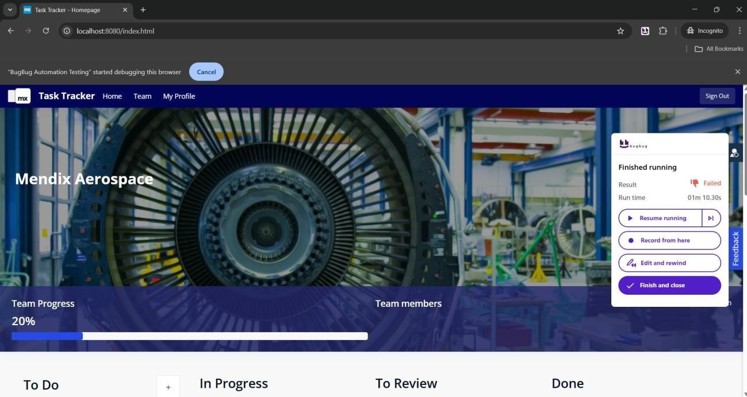

**Role Based Access Control Failed- links can be bypassed**

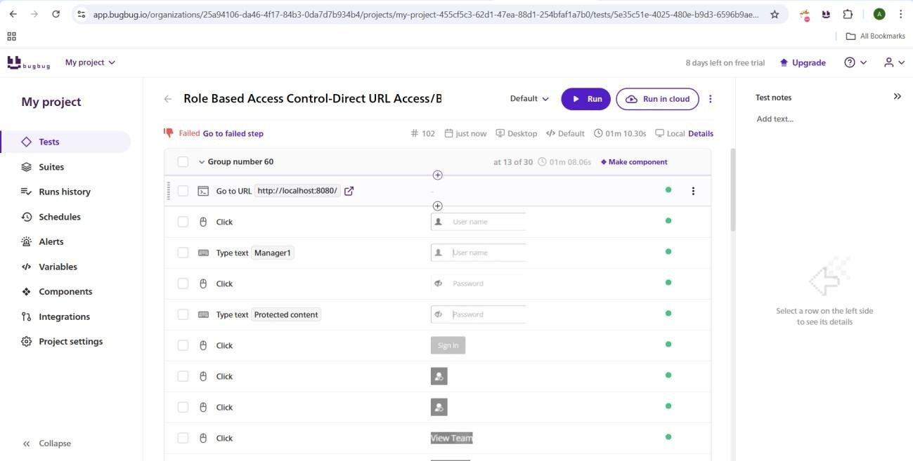

**Result:** **FAILED** – Member1 bypassed restrictions and accessed Manager-only pages.

**Risk:**

* Likelihood: High
* Impact: Critical

**Recommendation:**

* Immediately fix RBAC enforcement.
* Perform code audits & penetration testing.
* Add automated alerts for access violations.
* Integrate BugBug testing in CI/CD.
* Update scenarios regularly.
* Conduct manual penetration testing for high-risk modules.

**Overall Recommendations (All Apps)**

* Automate testing pipelines.
* Regularly update tests with feature changes.
* Save detailed logs/screenshots for audit.
* Strengthen RBAC with proactive monitoring.